## SmartWasteNet: A Deep Learning Framework to Transition from Take-Make-Waste to Rethink-Redesign-Reuse for Circular Economy Under SDG 12

*A Project Report submitted in the partial fulfillment of the Requirements for the award of the degree*

#### BACHELOR OF TECHNOLOGY

**IN**

#### COMPUTER SCIENCE AND ENGINEERING

###### Submitted by

**SK. Rasheed (22471A05J3)**

**V. Hemanth (22471A05K5)**

**K. Chandra Sekar (22471A05I5)**

Under the esteemed guidance of

**Dr. S. N. Tirumala Rao, M.Tech., Ph.D.**

**Professor & HOD**



#### DEPARTMENT OF COMPUTER SCIENCE AND ENGINEERING

NARASARAOPETA ENGINEERING COLLEGE: NARASAROPET

(AUTONOMOUS)

Accredited by NAAC with A+ Grade and NBA under Tier-1 and an ISO 9001:2015 Certified

Approved by AICTE, New Delhi, Permanently Affiliated to JNTUK, Kakinada

KOTAPPAKONDA ROAD, YALLAMANDA VILLAGE, NARASARAOPET- 522601

2025-2026

#### NARASARAOPETA ENGINEERING COLLEGE

**(AUTONOMOUS)**

#### DEPARTMENT OF COMPUTER SCIENCE AND ENGINEERING



**CERTIFICATE**

**This is to certify that the project that is entitled with the name “SMARTWASTENET: A DEEP LEARNING FRAMEWORK TO TRANSITION FROM TAKE-MAKE-WASTE TO RETHINK-REDESIGN-REUSE FOR CIRCULAR ECONOMY UNDER SDG 12” is a bonafide work done by the team SK. Rasheed (22471A05J3), V.Hemanth (22471A05K5) and K. Chandra Sekar (22471A05I5) in partial fulfillment of the requirements for the award of the degree of BACHELOR OF TECHNOLOGY in the Department of COMPUTER SCIENCE AND ENGINEERING during 2025-2026.**

PROJECT GUIDE PROJECT CO-ORDINATOR

**Dr. S. N. Tirumala Rao, M.Tech., Ph.D. D.Venkata Reddy ,B.Tech.,M.Tech., (Ph.D).**

**Professor & HOD Assistant Professor**

HEAD OF THE DEPARTMENT EXTERNAL EXAMINER

**Dr. S. N. Tirumala Rao, M.Tech., Ph.D.**

**Professor & HOD**

### DECLARATION

We declare that this project work titled "**SMARTWASTENET: A DEEP LEARNING FRAMEWORK TO TRANSITION FROM TAKE-MAKE-WASTE TO RETHINK-REDESIGN-REUSE FOR CIRCULAR ECONOMY UNDER SDG 12”** is composed by us that the work contain here is our own except where explicitly stated otherwise in the text and that this work has not been submitted for any other degree or professional qualification except as specified.

**SK. Rasheed (22471A05J3)**

**V. Hemanth (22471A05K5)**

**K. Chandra Sekar (22471A05I5)**

### ACKNOWLEDGEMENT

We wish to express our thanks to various personalities who are responsible for the completion of my project. We are extremely thankful to our beloved chairman**,** **Sri M. V. Koteswara Rao, B.Sc.** who took keen interest in us in every effort throughout this course. We owe our sincere gratitude to our beloved principal**, Dr. S. Venkateswarlu, Ph.D.** for showing his kind attention and valuable guidance throughout the course.

We express our deep-felt gratitude towards **Dr. S. N. Tirumala Rao, M.Tech., Ph.D.** HOD of the CSE department, and also our project guide**,** whose valuable guidance and unstinting encouragement enabled us to accomplish our project successfully in time.

We extend our sincere thanks to **D. Venkata Reddy, B.Tech., M.Tech., (Ph.D.)** Assistant Professor & Project Coordinator of the project, for extending his encouragement. Their profound knowledge and willingness have been a constant source of inspiration for us throughout this project work.

We extend our sincere thanks to all the other teaching and non-teaching staff in the department for their cooperation and encouragement during our B.Tech degree.

We have no words to acknowledge the warm affection, constant inspiration, and encouragement that we received from our parents.

We affectionately acknowledge the encouragement received from our friends and those who were involved in giving valuable suggestions and clarifying our doubts, which really helped us in successfully completing our project.

**By**

**SK. Rasheed (22471A05J3)**

**V. Hemanth (22471A05K5)**

**K. Chandra Sekar (22471A05I5)**



### INSTITUTE VISION AND MISSION

#### INSTITUTION VISION

To emerge as a Centre of excellence in technical education with a blend of effective student centric teaching learning practices as well as research for the transformation of lives and community.

#### INSTITUTION MISSION

**M1:** Provide the best class infra-structure to explore the field of engineering and research

**M2:** Build a passionate and a determined team of faculty with student centric teaching, imbibing experiential, innovative skills

**M3:** Imbibe lifelong learning skills, entrepreneurial skills and ethical values in students for addressing societal problems



### DEPARTMENT OF COMPUTER SCIENCE AND ENGINEERING

#### VISION OF THE DEPARTMENT

To become a center of excellence in nurturing the quality Computer Science & Engineering professionals embedded with software knowledge, aptitude for research and ethical values to cater to the needs of industry and society.

#### MISSION OF THE DEPARTMENT

The department of Computer Science and Engineering is committed to

**M1:** Mould the students to become Software Professionals, Researchers and Entrepreneurs by providing advanced laboratories.

**M2:** Impart high quality professional training to get expertize in modern software tools and technologies to cater to the real time requirements of the Industry.

**M3:** Inculcate team work and lifelong learning among students with a sense of societal and ethical responsibilities.



### Program Specific Outcomes (PSO’s)

**PSO1:** Apply mathematical and scientific skills in numerous areas of Computer Science and Engineering to design and develop software-based systems.

**PSO2:** Acquaint module knowledge on emerging trends of the modern era in Computer Science and Engineering

**PSO3:** Promote novel applications that meet the needs of entrepreneur, environmental and social issues.



### Program Educational Objectives (PEO’s)

The graduates of the program are able to:

**PEO1:** Apply the knowledge of Mathematics, Science and Engineering fundamentals to identify and solve Computer Science and Engineering problems.

**PEO2:** Use various software tools and technologies to solve problems related to the academia, industry and society.

**PEO3:** Work with ethical and moral values in the multi-disciplinary teams and can communicate effectively among team members with continuous learning.

**PEO4:** Pursue higher studies and develop their career in software industry.



### Program Outcomes

# **PO1: Engineering Knowledge**: Apply knowledge of mathematics, natural science,computing, engineering fundamentals and an engineering specialization as specified in WK1 to WK4 respectively to develop to the solution of complex engineering problems.

# **PO2: Problem Analysis**: Identify, formulate, review research literature and analyze complex engineering problems reaching substantiated conclusions with consideration for sustainable development. (WK1 to WK4)

# **PO3: Design/Development of Solutions**: Design creative solutions for complex engineering problems and design/develop systems/components/processes to meet identified needs with consideration for the public health and safety, whole-life cost, net zero carbon, culture, society and environment as required. (WK5)

# **PO4: Conduct Investigations of Complex Problems**: Conduct investigations of complex engineering problems using research-based knowledge including design of experiments, modelling, analysis & interpretation of data to provide valid conclusions. (WK8).

# **PO5: Engineering Tool Usage**: Create, select and apply appropriate techniques, resources and modern engineering & IT tools, including prediction and modelling recognizing their limitations to solve complex engineering problems. (WK2 and WK6)

# **PO6: The Engineer and The World**: Analyze and evaluate societal and environmental aspects while solving complex engineering problems for its impact on sustainability with reference to economy, health, safety, legal framework, culture and environment. (WK1, WK5, and WK7).

# **PO7: Ethics**: Apply ethical principles and commit to professional ethics, human values, diversity and inclusion; adhere to national & international laws. (WK9)

# **PO8: Individual and Collaborative Team work**: Function effectively as an individual, and as a member or leader in diverse/multi-disciplinary teams.

# **PO9: Communication**: Communicate effectively and inclusively within the engineering community and society at large, such as being able to comprehend and write effective reports and design documentation, make effective presentations considering cultural, language, and learning differences.

# **PO10: Project Management and Finance**: Apply knowledge and understanding of engineering management principles and economic decision-making and apply these to one’s own work, as a member and leader in a team, and to manage projects and

# in multidisciplinary environments.

# **PO11: Life-Long Learning**: Recognize the need for, and have the preparation and ability for i) independent and life-long learning ii) adaptability to new and emerging technologies and iii) critical thinking in the broadest context of technological change.



### 

### Project Course Outcomes (CO’S):

**CO421.1:** Analyse the System of Examinations and identify the problem.

**CO421.2:** Identify and classify the requirements. **CO421.3:** Review the Related Literature **CO421.4:** Design and Modularize the project

**CO421.5:** Construct, Integrate, Test and Implement the Project.

**CO421.6:** Prepare the project Documentation and present the Report using appropriate method.

**Course Outcomes – Program Outcomes mapping**

|  |  |  |  |  |  |  |  |  |  |  |  |  |  |  |
| --- | --- | --- | --- | --- | --- | --- | --- | --- | --- | --- | --- | --- | --- | --- |
|  | PO1 | PO2 | PO3 | PO4 | PO5 | PO6 | PO7 | PO8 | PO9 | PO10 | PO11 | PSO1 | PSO2 | PSO3 |
| **C421.1** |  | ✓ |  |  |  |  |  |  |  |  |  | ✓ |  |  |
| **C421.2** | ✓ |  | ✓ |  | ✓ |  |  |  |  |  |  | ✓ |  |  |
| **C421.3** |  |  |  | ✓ |  | ✓ | ✓ | ✓ |  |  |  | ✓ |  |  |
| **C421.4** |  |  | ✓ |  |  | ✓ | ✓ | ✓ |  |  |  | ✓ | ✓ |  |
| **C421.5** |  |  |  |  | ✓ | ✓ | ✓ | ✓ | ✓ | ✓ | ✓ | ✓ | ✓ | ✓ |
| **C421.6** |  |  |  |  |  |  |  |  | ✓ | ✓ | ✓ | ✓ | ✓ |  |

**Course Outcomes – Program Outcome correlation**

|  |  |  |  |  |  |  |  |  |  |  |  |  |  |  |
| --- | --- | --- | --- | --- | --- | --- | --- | --- | --- | --- | --- | --- | --- | --- |
|  | PO1 | PO2 | PO3 | PO4 | PO5 | PO6 | PO7 | PO8 | PO9 | PO10 | PO11 | PSO1 | PSO2 | PSO3 |
| **C421.1** | 2 | 3 |  |  |  |  |  |  |  |  |  | 2 |  |  |
| **C421.2** |  |  | 2 |  | 3 |  |  |  |  |  |  | 2 |  |  |
| **C421.3** |  |  |  | 2 |  | 2 | 3 | 3 |  |  |  | 2 |  |  |
| **C421.4** |  |  | 2 |  |  | 1 | 1 | 2 |  |  |  | 3 | 2 |  |
| **C421.5** |  |  |  |  | 3 | 3 | 3 | 2 | 3 | 2 | 2 | 3 | 2 | 1 |
| **C421.6** |  |  |  |  |  |  |  |  | 3 | 2 | 1 | 2 | 3 |  |

**Note: The values in the above table represent the level of correlation**

**between CO’s and PO’s:**

1. Low level
2. Medium level
3. High level

**Project mapping with various courses of Curriculum with Attained PO’s:**

|  |  |  |
| --- | --- | --- |
| **Name of the course from which principles are applied in this project** | **Description of the device** | **Attained PO** |
| **C2204.2, C22L3.2** | Requirements were gathered from municipal waste data and SDG indicators to define an AI-based circular economy classification model. | PO1, PO3,PO8 |
| **CC421.1, C2204.3, C22L3.2** | Project requirements were critically analyzed to select suitable preprocessing, feature engineering, and deep learning techniques. | PO2, PO3, PO8 |
| **CC421.2, C2204.2, C22L3.3** | A modular system architecture was designed incorporating data preprocessing, clustering, classification, and explainability. | PO3, PO5, PO9, PO8 |
| **CC421.3, C2204.3, C22L3.2** | All system modules were tested, integrated, and evaluated using standard performance metrics to ensure reliability. | PO1, PO5, PO8 |
| **CC421.4, C2204.4, C22L3.2** | Complete project documentation was collaboratively prepared covering design, methodology, and results. | PO10, PO8 |
| **CC421.5, C2204.2, C22L3.3** | Project phases were periodically reviewed and presented, highlighting development progress and outcomes. | PO8,PO10, PO11 |
| **C2202.2, C2203.3,**  **C1206.3, C3204.3,**  **C4110.2** | The SmartWasteNet system was implemented using real-world city-level data with scope for future smart city integration. | PO4, PO7, PO8 |
| **C32SC4.3** | A web-based dashboard was developed to visualize waste trends, clustering results, and circular economy recommendations. | PO5, PO6, PO8 |

### ABSTRACT

**The rapid urbanization happening in India has resulted in a significant increase in municipal solid waste (MSW), which calls for creative and sustainable waste management strategies. This project introduces a deep learning framework that aligns with the circular economy principles—Rethink, Redesign, Reuse—to support Sustainable Development Goal 12 (SDG 12). By gathering data from 59 Indian cities, including MSW generation, recycling rates, SDG indicators, and city demographics, we created a comprehensive dataset for analysis. To cluster cities based on circularity indicators, we used an unsupervised learning approach with an autoencoder, assigning each city a relevant circular economy action. We trained five supervised deep learning models (MLP with 1-layer, 2-layer, Dropout, Batch Normalization, and WideDeep MLP) to classify cities into these actions. Notably, the Dropout_MLP model stood out, achieving an impressive 97.86% accuracy in classifying circular economy actions. To enhance model interpretability, we utilized SHAP, which helped identify key features that influence decisions, such as SDG scores and recycling efficiency. This framework not only predicts waste patterns but also offers practical circular economy recommendations tailored for each city. It's designed to be scalable and explainable, providing urban policymakers with the insights they need to make informed, sustainable decisions that promote a circular economy.**

S.NO CONTENT

### INDEX

PAGE NO

1. INTRODUCTION 1
   1. MOTIVATION 4
   2. PROBLEM STATEMENT 5

1.3 OBJECTIVE 6

1. LITERATURE SURVEY 7
2. SYSTEM ANALYSIS
   1. EXISTING SYSTEM 12
      1. DISADVANTAGES OF THE EXISTING SYSTEM 14
   2. PROPOSED SYSTEM 14
   3. FEASIBILITY STUDY 16
3. SYSTEM REQUIREMENTS
   1. SOFTWARE REQUIREMENTS 19
   2. REQUIREMENT ANALYSIS 19
   3. HARDWARE REQUIREMENTS 21
   4. SOFTWARE DESCRIPTION 21
4. SYSTEM DESIGN
   1. SYSTEM ARCHITECTURE 22
      1. DATASET DESCRIPTION 24
      2. DATA PREPROCESSING 25
      3. FEATURE EXTRACTION 27
      4. MODEL BUILDING 29
      5. CLASSIFICATION 33
   2. MODULES 35
   3. UML DIAGRAMS 38
5. IMPLEMENTATION
   1. MODEL IMPLEMENTATION 42
   2. CODING 45
6. TESTING
   1. UNIT TESTING 55
   2. INTEGRATION TESTING 55
   3. SYSTEM TESTING 56
7. RESULT ANALYSIS 58
8. OUTPUT SCREENS 62
9. CONCLUSION 65
10. FUTURE SCOPE 66
11. REFERENCES 68

### 

### LIST OF FIGURES

**S.NO FIGURE DESCRIPTION PAGE**

**NO**

1. **FIG 1 SMARTWASTENET FRAMEWORK OVERVIEW 3**
2. FIG 2 FLOW CHART OF EXISTING SYSTEM 13
3. FIG 3 SYSTEM ARCHITECTURE 22
4. FIG 4 AUTOENCODER-BASED FEATURE EXTRACTION PROCESS FOR SMARTWASTENET 29
5. FIG 5 MODEL BUILDING WORKFLOW FOR SMARTWASTENET 32
6. FIG 6 UML USECASE DIAGRAM FOR SMARTWASTENET **39**
7. **FIG 7 UML ACTIVITY DIAGRAM FOR SMARTWASTENET 40**
8. **FIG 8 UML SEQUENCE DIAGRAM FOR SMARTWASTE**  41
9. FIG 9 MODEL EVALUATION METRIC 58
10. FIG 10 EXPLAINABILITY ANALYSIS USING SHAP 59
11. FIG 11 CONFUSION MATRIX FOR DROPOUT MLP MODEL 61
12. FIG 12 HOME PAGE 62
13. FIG 13 ABOUT PAGE 62
14. FIG 14 OBJECTIVES PAGE 63
15. FIG 15 OBJECTIVES PAGE 63
16. FIG 16 PREDICTION PAGE 64
17. FIG 17 RESULT PAGE 64

**List of Tables**

|  |  |  |
| --- | --- | --- |
| S.NO | CONTENT | PAGE NO |

1. TABLE 1. KEY FEATURES AND THEIR DESCRIPTIONS IN THE SMARTWASTENET DATASET 25
2. TABLE 2. KEY EXTRACTED FEATURES AND THEIR DESCRIPTIONS 28
3. TABLE 3: OVERVIEW OF MLP MODELS USED FOR CLASSIFICATION 31
4. TABLE 4: PERFORMANCE COMPARISON OF MLP MODELS FOR CIRCULAR ECONOMY ACTION CLASSIFICATION 34
5. MODEL PERFORMANCE COMPARISON OF DIFFERENT CLASSIFIERS 60

### INTRODUCTION

The increasing pace of urbanization in India has led to a surge in municipal solid waste (MSW) generation, creating one of the most pressing environmental and public health challenges of modern times. Rapid population growth, industrial expansion, and inadequate infrastructure have strained existing waste management systems, resulting in inefficient resource use and increased pollution. The conventional Take–Make–Waste linear production model, which emphasizes consumption and disposal, has proven unsustainable in the face of mounting environmental degradation. To counter this, there is a growing need for innovative frameworks that promote circular economy (CE) practices, ensuring resources are continually reused, redesigned, and rethought to minimize waste and environmental impact.

Aligned with the United Nations Sustainable Development Goal 12 (SDG 12) — Responsible Consumption and Production — the concept of a circular economy emphasizes a regenerative system designed to keep materials in use for as long as possible. The three core principles of the CE model — **Rethink, Redesign and Reuse** — aim to transform traditional waste management into a sustainable, closed-loop system. However, while CE practices have been studied in industries such as manufacturing, construction, and e-waste management, there remains a significant gap in data-driven, city-level frameworks capable of providing actionable insights for policymakers, particularly within the Indian context.

To address this gap, **SmartWasteNet** introduces a deep learning-based analytical framework that integrates data science, artificial intelligence (AI), and sustainability analytics to enhance circular economy adoption across Indian cities. The framework leverages waste generation data, recycling efficiency, SDG performance indicators, and demographic attributes from 59 cities across India. Using this diverse dataset, the system applies advanced neural network techniques to identify patterns, predict sustainability actions, and recommend practical interventions suited to each city’s waste management profile.

The SmartWasteNet framework utilizes **autoencoder-based clustering** to discover hidden sustainability patterns and group cities into clusters that represent varying levels of circular economy maturity. These clusters are then mapped to three actionable strategies — Rethink, Redesign, and Reuse — based on city-level waste generation intensity, recycling performance, and SDG 12 alignment. Once these labels are established, **supervised deep learning models**, including Multi-Layer Perceptron (MLP) variants such as Dropout MLP and Batch Normalization MLP, are trained to classify cities into the appropriate circular action category.

Among the models evaluated, the **Dropout MLP** architecture demonstrated the best performance, achieving an impressive accuracy of **97.86%**. This indicates that deep learning models, when trained on integrated sustainability and waste datasets, can effectively differentiate cities based on their readiness and efficiency in adopting circular economy practices. The use of dropout layers significantly reduced overfitting and improved generalization, proving that even with a relatively small dataset, robust predictive performance can be achieved through careful model design and regularization techniques.

A unique aspect of SmartWasteNet lies in its **explainable AI (XAI)** component, implemented through SHAP (SHapley Additive exPlanations). This interpretability layer enhances model transparency by identifying key features that drive the model’s predictions, such as SDG 12 scores, recycling rates, and population density. By visualizing the influence of each parameter on the predicted circular action, the framework provides decision-makers with a clear understanding of which factors most significantly affect city-level sustainability outcomes.

The integration of clustering, classification, and explainability within a single framework bridges the existing gap between data-driven analytics and policy-level decision support. SmartWasteNet thus acts as a practical decision-support tool for urban administrators, enabling them to identify which cities require fundamental system changes (Rethink), design innovations (Redesign), or improved recycling and resource recovery initiatives (Reuse). These insights can help local governments prioritize interventions, allocate resources efficiently, and monitor progress toward achieving SDG 12. The SmartWasteNet framework is not only a technological innovation but also a strategic step toward achieving sustainability at the city governance level.

By combining data analytics with environmental science, it bridges the gap between complex waste data and actionable urban policies. Through its integration of autoencoders for pattern discovery, deep neural networks for prediction, and SHAP for interpretability, the framework offers a comprehensive solution that connects artificial intelligence with environmental management.

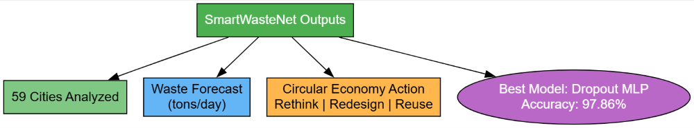

**Fig 1: SmartWasteNet Framework Overview**

In essence, SmartWasteNet signifies a transformative approach to waste management — one that shifts focus from reactive collection and disposal to proactive prediction and circular design. By aligning deep learning with sustainability goals, this research paves the way for smarter, data-driven cities capable of transitioning from the traditional Take–Make–Waste model to a Rethink–Redesign–Reuse paradigm, reinforcing India’s commitment to a circular, resource-efficient future.

In conclusion, the research presented in this study demonstrates how deep learning can serve as a critical enabler for the circular economy, especially under SDG 12. SmartWasteNet represents a scalable, explainable, and high-performing AI framework that guides Indian cities toward sustainable consumption and production pathways. By providing accurate forecasts, actionable recommendations, and transparent insights, it sets the foundation for smarter waste management systems and long-term policy innovation. Ultimately, this work highlights how technology-driven sustainability frameworks can redefine the future of waste management, ensuring that cities evolve into cleaner, circular, and more resilient ecosystems.

##### Motivation

The alarming growth of municipal solid waste (MSW) across Indian cities has emerged as a critical challenge to sustainable urban development. Traditional waste management systems are struggling to cope with increasing population density, unplanned urbanization, and limited recycling infrastructure. The prevalent Take–Make–Waste model has resulted in excessive resource extraction and landfill accumulation, posing severe threats to public health and the environment. These challenges underscore the urgent need for data-driven, intelligent systems capable of transforming raw waste data into actionable insights that support responsible consumption and production — a key focus of the United Nations Sustainable Development Goal 12 (SDG 12).

Although several studies have explored circular economy (CE) strategies across industrial and environmental sectors, very few have addressed how artificial intelligence (AI) and machine learning can be effectively applied to waste management at the city level. Most existing frameworks lack scalability, interpretability, and decision-making support, making it difficult for policymakers to identify which regions need system redesigns, behavioral shifts, or infrastructure upgrades. This research is motivated by the need to fill that gap by developing a robust AI-based framework that not only predicts waste patterns but also classifies cities according to their circular economy readiness, offering transparent and evidence-based recommendations for sustainable transformation.

The motivation behind SmartWasteNet lies in bridging the divide between data analytics and practical policy implementation. By leveraging deep learning models and explainable AI techniques, the framework empowers stakeholders to understand the underlying factors influencing waste generation and recycling performance. It provides a scientific foundation for recommending circular actions such as Rethink, Redesign, and Reuse, thereby enabling cities to transition toward sustainable, resource-efficient models. Ultimately, the goal is to promote an AI-driven approach to sustainability — one that not only enhances environmental resilience but also supports long-term circular economy planning and innovation in India’s urban landscape.

##### Problem Statement

The exponential growth of municipal solid waste (MSW) in India has become a pressing urban challenge, threatening both environmental sustainability and public health. Existing waste management systems often rely on fragmented data, manual segregation processes, and reactive decision-making, which result in inefficient recycling and resource utilization. Despite various initiatives to promote sustainability, the absence of a unified, data-driven framework to assess, predict, and guide waste management practices has limited the effectiveness of current policies. This problem calls for a more intelligent approach that can analyze complex urban datasets and provide clear, actionable insights to help cities transition toward a circular economy.

Traditional waste management follows the Take–Make–Waste model, where materials are extracted, consumed, and discarded without significant recovery or reuse. This linear system has led to mounting landfills, air and water pollution, and increased greenhouse gas emissions. While the concept of the circular economy (CE) offers a solution by emphasizing Rethink, Redesign, and Reuse strategies, city-level implementation in India remains minimal. The main barrier lies in the lack of AI-based tools capable of identifying waste generation trends, clustering cities by sustainability performance, and recommending specific CE actions that are data-informed and locally applicable.

To address these issues, the research proposes **SmartWasteNet**, a deep learning framework designed to bridge the gap between data analytics and sustainable policy action. The problem being solved is not only about predicting waste quantities but about understanding the why behind those patterns — identifying which socio-economic and environmental factors contribute to waste inefficiencies and how they can be mitigated through targeted interventions. SmartWasteNet aims to empower city administrators and policymakers with explainable, AI-driven decision support, enabling them to design smarter, circular systems that reduce waste, enhance recycling efficiency, and align local governance with the principles of SDG 12.

##### 1.3 Objective

The primary objective of this research is to design and develop an intelligent, data-driven framework—**SmartWasteNet**—that facilitates the transition from the traditional Take–Make–Waste model to a sustainable Rethink–Redesign–Reuse circular economy paradigm under Sustainable Development Goal 12 (SDG 12). The framework aims to leverage deep learning and explainable AI techniques to analyze municipal solid waste (MSW) data, sustainability indicators, and city-level demographics to identify patterns, predict waste trends, and recommend actionable circular economy strategies tailored to each city’s unique waste management profile.

Another key objective is to build a **hybrid deep learning architecture** that integrates unsupervised and supervised learning techniques for improved accuracy and interpretability. Through **autoencoder-based clustering**, the study seeks to group cities according to their circularity performance, while **Multi-Layer Perceptron (MLP)** classifiers are employed to predict and assign cities to specific CE actions—Rethink, Redesign, or Reuse. The project further incorporates **SHAP explainability** to highlight the most influential features, such as SDG12 score, recycling rate, and population density, ensuring that the model’s recommendations are transparent and understandable to policymakers and urban planners.

Finally, this research aims to create a **decision-support system** that bridges the gap between complex AI outputs and real-world policy applications. By offering interpretable insights and visual representations, SmartWasteNet seeks to empower urban stakeholders to make informed decisions, design sustainable waste management strategies, and prioritize interventions based on city-level performance. The ultimate objective is to promote scalable, explainable, and actionable intelligence that supports India’s journey toward responsible consumption, production, and long-term environmental resilience.

#### LITERATURE SURVEY

**Md. R. Hasan** [1] conducted a comparative study of forecasting algorithms—ANN, ARIMA, and SVR—for municipal solid waste (MSW) prediction in Chittagong City. Their results highlighted ANN’s superior performance in capturing seasonal trends and reducing RMSE/MAE, motivating the use of neural networks for accurate waste forecasting in urban contexts.

I. Kayan [2] integrated Response Surface Methodology (RSM) with decision-tree algorithms to optimize pollutant removal from cheese whey using marine microalgae. The study demonstrates how hybrid analytical and machine-learning methods can improve environmental resource recovery, an approach conceptually relevant for circular-economy optimization.

C. Bosco [3] developed a multi-dimensional sustainability assessment framework for water-sector circular economy solutions. Their systematic methodology for quantifying “smartness” and sustainability in water systems provides a useful parallel for designing evaluation metrics in urban waste and circularity studies.

M. M. Jayalath [4] used the Analytical Hierarchy Process (AHP) to analyze waste flows in agri-food supply chains, underscoring the importance of structured decision-making for optimizing resource flows. Their work shows how multi-criteria methods can complement data-driven models when designing circular interventions.

S. Jadhav and S. Patil [5] reviewed sustainable temporary housing and reuse strategies for post-disaster scenarios, emphasizing reuse-based solutions. Their bibliometric and thematic insights reinforce the relevance of reuse strategies—one of SmartWasteNet’s three core CE actions—for resource-constrained contexts.

T. Patil [6] surveyed agrivoltaics technologies for net-zero carbon goals and highlighted synergies among energy, food, and land-use metrics. The multi-sector approach illustrated here is instructive for expanding circularity assessments beyond waste to include energy and land-use sustainability.

A. Kulkarni and K. Ramesh [7] presented material-substitution strategies that use industrial waste (e.g., eggshells, leather) for energy-efficient concrete production, demonstrating measurable CO₂ reductions. This is an applied example of design-for-reuse that supports circular economy policy levers.

P. S. and V. Sharma [8] examined acid-based upcycling of construction and demolition waste, showing mechanical property improvements when substituting binder fractions—evidence of practical redesign approaches that align with SmartWasteNet’s Redesign recommendations.

A. Verma and R. Singh [9] offered a comprehensive review of fashion and textile waste management within the circular economy, reporting the dominance of waste-management research and cataloguing recycling technologies. Their sectoral review emphasizes tailoring CE recommendations to domain-specific constraints.

N. Bansal and R. Patel [10] explored business-model enablers for green transitions in circular waste management, identifying economic incentives and community-driven segregation as critical factors—insights that support incorporating socio-economic features into CE classification models.

M. Marmion [11] applied supervised learning and bioimpedance features for agricultural classification tasks, achieving high F1-scores. Their methodological rigor in feature engineering and model validation serves as a cross-domain example for robust ML pipelines in environmental datasets.

The World Bank’s What a Waste 2.0 [12] provides the authoritative global dataset and projections for waste generation to 2050; it functions as a baseline for validating city-level MSW statistics and benchmarking SmartWasteNet’s forecasting outputs.

The Central Pollution Control Board’s Hazardous Waste Inventory [13] served as a national-level validation source in the paper. CPCB data underpins accurate hazardous-waste profiling and complements municipal MSW datasets for comprehensive city-level assessments.

NITI Aayog’s SDG India Index [14] offers city/state SDG performance metrics—especially SDG 12 indicators—used by SmartWasteNet as key explanatory variables. The index’s standardized scoring enables cross-city comparisons and policy-aligned feature selection.

K. Lakshminadh [15] demonstrated deep-learning-based pest identification using VGG networks, illustrating how pre-trained CNN architectures can be repurposed for domain-specific classification—an approach analogous to transfer learning for environmental image or sensor data.

B. Greeshma [16] applied CNNs to arrhythmia detection, highlighting the importance of deep architectures and signal preprocessing. Their success in medical signal classification emphasizes the general utility of deep networks for structured, noisy datasets such as urban sensor readings.

M. Sireesha [17] introduced hybrid optimization methods for feature selection, offering strategies for selecting informative predictors in high-dimensional problems. Their hybrid metaheuristic approach can be adapted to select the most relevant sustainability indicators for SmartWasteNet.

D. Venkatareddy [18] combined explainable AI techniques (CNN + MLP) for ultrasound classification, stressing model interpretability in sensitive domains. Their work supports SmartWasteNet’s decision to incorporate SHAP for transparent policy recommendations.

S. N. T. Rao et al. (2025) [19] introduced a deep learning-based tomato leaf disease identification model using the AlexNet architecture, demonstrating how convolutional neural networks can automate agricultural disease diagnosis with high accuracy. Their work emphasizes the importance of **transfer learning and optimized feature extraction**, proving that DL models significantly outperform

traditional machine learning in fine-grained classification tasks. This study establishes a strong foundation for applying advanced neural architectures for vision-based classification in real-world domains.

S. S. N. Rao et al. (2025) [20] proposed an **advanced water quality prediction model integrating genetic optimization with machine learning**, where genetic algorithms were used for optimal feature selection and hyperparameter tuning. Their results highlight that **hybrid intelligence models improve predictive accuracy** in environmental datasets, particularly where water resource parameters fluctuate dynamically. This research shows how optimization-assisted learning can improve sustainability and environmental monitoring.

M. F. Ali (2024) [21] presented a comprehensive study on **data analytics for urban waste management and SDG monitoring**, demonstrating how analytical pipelines and big data modeling can support evidence-based policymaking in smart city frameworks. The study underscores the role of **data-driven decisions in waste forecasting, recycling efficiency tracking, and sustainable resource planning**, contributing effectively to SDG-aligned municipal governance.

UN-Habitat (2024) [22] published a **global review on sustainable urban waste practices**, documenting the latest innovations, circular economy models, community-driven waste programs, and policy recommendations across countries. The review emphasizes the urgency of **reducing landfill dependency, improving recycling ecosystems, and fostering responsible consumption and production**, serving as a crucial benchmark report for researchers developing sustainability and SDG-focused technological frameworks.

Several referenced domain-specific studies collectively reinforce the methodological building blocks used in SmartWasteNet: (a) careful preprocessing and feature engineering, (b) dimensionality reduction/representation learning, and (c) rigorous model evaluation with cross-validation and explainability—practices shown to yield robust, interpretable results across domains.

The body of literature summarized above indicates a convergence between environmental science, policy indices (e.g., SDG scores), and machine learning techniques. From forecasting MSW (ANN/ARIMA/SVR) to unsupervised representation learning (autoencoders) and explainable classifiers (MLP + SHAP), these works provide both the empirical datasets and methodological precedent that underpin SmartWasteNet’s design and validate its contributions to data-driven circular economy decision support.

Recent studies have emphasized the transformative role of **deep learning and artificial intelligence in sustainable waste management systems**. Researchers have developed neural models that integrate socio-economic, environmental, and waste-generation factors to predict municipal solid waste more accurately. For instance, hybrid architectures combining **LSTM networks** with **autoencoders** have been employed to capture both temporal trends and hidden correlations among waste indicators, providing superior forecasting accuracy over traditional time-series models.

These approaches underscore the potential of advanced deep learning frameworks like SmartWasteNet to improve waste pattern analysis and policy planning.

The adoption of **explainable AI (XAI)** in environmental decision-making has gained momentum in recent years. Traditional black-box models often deliver high accuracy but lack interpretability, which limits their application in policy domains where transparency is essential. Techniques such as **SHAP (SHapley Additive exPlanations)** and **LIME (Local Interpretable Model-Agnostic Explanations)** have emerged as reliable methods for feature attribution and model explanation. In SmartWasteNet, SHAP plays a crucial role in identifying the most influential sustainability indicators—such as SDG 12 scores, recycling rates, and population density—thereby bridging the gap between predictive analytics and actionable environmental insights.

Several research works have explored **AI-driven frameworks for urban sustainability and circular economy modeling**. Studies using clustering algorithms like **K-Means, DBSCAN, and Self-Organizing Maps (SOM)** have successfully grouped cities or industries based on environmental performance metrics. These clustering results often inform policy segmentation, where similar regions share tailored sustainability interventions. SmartWasteNet builds upon this concept by using **autoencoder-based clustering**, a deep-learning variant that enhances dimensionality reduction and identifies latent structures in multi-indicator sustainability datasets.

From the reviewed studies, it is evident that deep learning and artificial intelligence have become powerful tools for advancing waste management and circular economy applications. Earlier works focused on forecasting, clustering, and classification models for sustainability assessment, but most lacked explainability and integrated policy relevance. SmartWasteNet bridges this gap by combining **autoencoder-based clustering**, **MLP classification**, and **SHAP explainability** to deliver accurate, interpretable, and actionable insights for city-level circular economy planning under **SDG 12**.

### SYSTEM ANALYSIS

#### EXISTING SYSTEM

The existing waste management and sustainability assessment systems in most Indian cities primarily rely on traditional, rule-based, and statistical methods. These systems collect basic municipal solid waste (MSW) data such as waste generated, collected, and disposed of, but lack advanced analytical capabilities to uncover hidden patterns or predict future waste trends. Traditional analytical tools, including regression-based or linear forecasting models, often fail to capture the complex interdependencies among demographic, environmental, and socio-economic indicators.

Moreover, most municipal corporations and policy agencies depend on static reports or manual analysis, which are time-consuming and often inconsistent across regions. As a result, city-level decision-making remains reactive rather than proactive, focusing on short-term waste collection and disposal rather than long-term sustainability planning. The linear **“Take–Make–Waste”** model continues to dominate urban waste systems, leading to inefficient recycling, rising landfill usage, and loss of valuable resources.

Although several pilot initiatives have promoted recycling and resource recovery, they operate in isolation without data-driven intelligence. The absence of machine learning-based predictive frameworks restricts policymakers from identifying circular economy (CE) opportunities and implementing targeted interventions at the city level. Hence, there is a strong need for an AI-driven, integrated solution that can provide transparency, predictive insights, and actionable recommendations for sustainable resource management.

The figure 3.1 illustrates the overall **workflow of the proposed SmartWasteNet framework**, which integrates multiple deep learning and analytical stages to recommend circular economy (CE) actions for sustainable waste management under SDG 12.

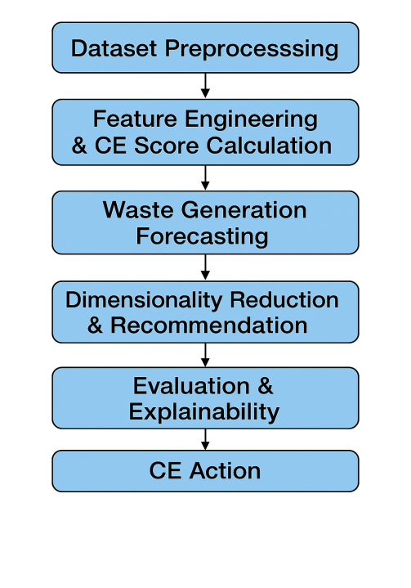

**FIG 2: FLOW CHART OF EXISTING SYSTEM**

1. The process begins with **Dataset Preprocessing**, where raw data from 59 Indian cities—covering municipal solid waste (MSW) generation, recycling rates, population density, and SDG indicators—is cleaned, normalized, and standardized to ensure data consistency.

2. Next, **Feature Engineering and CE Score Calculation** are performed to derive meaningful sustainability indicators such as waste per capita, recycling efficiency, and composite CE readiness scores. These engineered features provide valuable context for subsequent prediction and clustering tasks.

3. The **Waste Generation Forecasting** stage uses deep learning techniques to predict future waste quantities and identify cities with rising waste trends. This step helps policymakers anticipate resource requirements and implement preventive waste management strategies.

4. In **Dimensionality Reduction and Recommendation**, an **autoencoder** compresses high-dimensional features into a low-dimensional latent space, enabling clustering of cities based on their circularity performance. These clusters are then mapped to specific CE actions—**Rethink, Redesign, or Reuse**.

5. The **Evaluation and Explainability** stage applies metrics such as accuracy, precision, and F1-score to validate model performance. Additionally, **SHAP (SHapley Additive exPlanations)** is employed to interpret the model’s predictions, identifying the most influential sustainability factors behind each decision.

6. Finally, the **CE Action** output provides interpretable recommendations for each city, guiding policymakers toward actionable strategies to enhance recycling, reduce waste generation, and promote circular economy transitions at the urban level.

#### 3.1.1 DISADVANTAGES OF THE EXISTING SYSTEM

1. **Lack of Predictive Intelligence:** Existing systems cannot forecast future waste generation or recycling trends, resulting in inefficient planning and resource allocation.

**2**. **No Automated Decision Support:** Manual evaluation of reports delays the formulation of effective policies and sustainability actions.

**3**. **Limited Data Integration:** Environmental, demographic, and sustainability data are stored separately, preventing comprehensive analysis.

**4. Poor Interpretability:** Traditional models provide numerical outputs but do not explain why specific waste trends or sustainability patterns occur.

**5. Reactive Management:** Current systems focus on waste disposal rather than reduction, reuse, and redesign strategies aligned with SDG 12.

These limitations highlight the need for a smart, data-driven framework capable of bridging the gap between environmental analytics and circular economy implementation.

#### 3.2 PROPOSED SYSTEM

#### The proposed system, **SmartWasteNet**, introduces a **deep learning–based framework** to support circular economy transition under **Sustainable Development Goal 12 (SDG 12)**. It integrates municipal solid waste (MSW) statistics, recycling rates, SDG indicators, and city-level demographics from 59 Indian cities to form a unified dataset for sustainability analysis.

#### The system employs **autoencoder-based clustering** to uncover latent circularity patterns, grouping cities into actionable categories—**Rethink, Redesign, and Reuse.**

In the next phase, **Multi-Layer Perceptron (MLP)** models are trained to classify cities according to these CE action categories. Among five variants (1-layer, 2-layer, Dropout, BatchNorm, and WideDeep MLP), the **Dropout MLP** model achieved the highest accuracy of **97.86%**, demonstrating robust predictive performance and generalization. To ensure transparency, **SHAP (SHapley Additive exPlanations)** is used to identify the most influential factors driving classification results, such as SDG 12 score, recycling rate, and population density.

The SmartWasteNet system thus not only predicts waste management performance but also provides **explainable, city-specific recommendations** to help policymakers and municipal administrators make informed decisions. It shifts the paradigm from reactive waste management to proactive sustainability planning, enabling India’s urban centers to align with the principles of the circular economy.

The proposed **SmartWasteNet** system not only focuses on technical innovation but also emphasizes **policy integration and scalability**. By combining machine learning analytics with sustainability indicators, the framework bridges the gap between data science and environmental governance. Its modular design allows easy expansion to other cities, states, or even countries, while maintaining model adaptability through retraining with new datasets. Furthermore, by offering visual interpretability through SHAP plots and performance dashboards, SmartWasteNet ensures transparency and trust in AI-assisted decision-making. Ultimately, this system empowers policymakers, researchers, and municipal authorities to make data-informed decisions that accelerate the shift toward a **sustainable, circular, and smart urban ecosystem**.

**Advantages over Existing system:**

1. **Basic Waste Monitoring:**

The existing system provides fundamental tracking of municipal solid waste (MSW) generation, collection, and disposal at the city level.  
This baseline data helps municipalities maintain operational records and monitor waste flow.

1. **Regulatory Compliance:**

Traditional systems ensure that cities adhere to national waste management standards and regulations such as those issued by the Central Pollution Control Board (CPCB) and Swachh Bharat Mission guidelines.

1. **Ease of Implementation:**

Manual or spreadsheet-based approaches are simple to deploy, requiring minimal technical infrastructure and human resource training. This makes them accessible to smaller municipalities or regions with limited technological capabilities.

1. **Data Availability for Reporting:**

The existing waste data collection mechanisms provide inputs for state and national reporting frameworks, enabling annual assessments and comparisons across cities.

1. **Foundation for Future Automation:**

The structured data collected under the current system, though limited, serves as a foundation for integrating future AI and deep learning models like SmartWasteNet. This ensures continuity when transitioning to more advanced, automated systems.

#### 

#### 3.3 FEASIBILITY STUDY

A feasibility study is conducted to determine the practicality, efficiency, and viability of developing and implementing the proposed **SmartWasteNet** framework. It evaluates the technical, operational, and economic aspects to ensure that the system is both achievable and beneficial to its stakeholders.

###### Technical Feasibility

The technical feasibility evaluates whether the technology required for developing SmartWasteNet is available, reliable, and efficient. The proposed framework employs **deep learning algorithms** such as **Autoencoders** for dimensionality reduction and **Multi-Layer Perceptron’s (MLP)** for classification. These models are implemented using widely accessible machine learning libraries such as **TensorFlow**, **Keras**, **Scikit-learn**, and **Pandas** in a Python environment.

Additionally, the system uses structured datasets collected from reliable sources like the **NITI Aayog SDG Index**, **CPCB Reports**, and the **World Bank’s What a Waste 2.0 database**, which ensures data authenticity. The framework also incorporates **SHAP explainability tools**, which enhance interpretability without requiring specialized hardware. The entire system can be efficiently executed on a standard computing environment equipped with GPU or multi-core CPU capabilities. Therefore, the SmartWasteNet model is **technically feasible and scalable** for real-world deployment.

###### Operational Feasibility

Operational feasibility determines whether the proposed system can be effectively implemented and maintained in an organizational or policy-driven environment. The SmartWasteNet framework is designed with a modular workflow—from **data preprocessing** to **explainable classification**—ensuring clarity and ease of use. Policymakers, municipal officers, and sustainability analysts can operate the system through user-friendly dashboards or command-based interfaces.

Moreover, the model’s **explainable AI (XAI)** integration through SHAP allows non-technical users to understand the reasons behind each circular economy recommendation. This transparency enhances user confidence and supports decision-making for sustainable development planning. The system’s interpretability, adaptability, and automation make it **operationally feasible** for deployment across different cities and regions.

###### Economic Feasibility

Economic feasibility focuses on evaluating the cost-benefit balance of the proposed framework. The SmartWasteNet system relies on open-source libraries and freely available datasets, which minimizes the financial burden of development and maintenance. The initial cost primarily involves computing resources for model training and skilled personnel for system development and monitoring.

In comparison to traditional waste management strategies that require manual data collection, periodic surveys, and infrastructure-heavy interventions, SmartWasteNet offers **cost-effective digital intelligence** capable of improving efficiency and reducing long-term expenses. By enabling early identification of waste trends and actionable circular economy interventions, the system ensures high **return on investment (ROI)** for municipal administrations and sustainability departments. Thus, the framework is **economically viable and sustainable** for long-term adoption.

### 4. SYSTEM REQUIREMENTS

The SmartWasteNet framework integrates deep learning, sustainability analytics, and 2explainable AI for circular economy planning. To ensure smooth development and execution, both **software** and **hardware requirements** must be defined clearly.

**4.1 SOFTWARE REQUIREMENTS**

 Operating System : Windows 11, 64-bit Operating System

2. Hardware Accelator : CPU

 Coding Language : Python

 Development Environment : Google Colab , Flask

 Visualization Tools : Ploty, SHAP library for explainability

6. Libraries Used : NumPy, Pandas, Scikit-learn, Matplotlib

#### 4.2 REQUIREMENT ANALYSIS

Requirement analysis defines the functional and non-functional requirements of the proposed **SmartWasteNet** system. It ensures that all technical and user needs are identified before implementation to achieve efficient, explainable, and accurate performance.

### ****4.2.1 FUNCTIONAL REQUIREMENTS****

These requirements describe what the system must do — its core operations and functionalities.

1. **Data Integration:**

The system should collect and merge data from multiple sources, including waste generation, recycling rates, SDG indicators, and city demographics.

1. **Data Preprocessing:**

The framework must clean, normalize, and standardize datasets to ensure high quality inputs for deep learning models.

**3. Feature Engineering and Circularity Scoring:**

It should calculate composite sustainability indicators such as recycling efficiency, waste per capita, and SDG 12 contribution scores.

1. **Clustering and Classification:**

The system must apply **Autoencoder-based clustering** and **MLP classification** to assign cities to circular economy action labels — Rethink, Redesign, *or* Reuse.

1. **Explainable AI Analysis:**

The model should provide interpretability using **SHAP** to identify key influencing features for each decision.

1. **Visualization and Reporting:**

It must generate charts, heatmaps, and confusion matrices to display waste trends, model accuracy, and feature importance.

1. **Recommendation Generation:**

The final output should include **city-wise CE recommendations** that support policymakers in implementing circular economy strategies.

### ****4.2.2 NON-FUNCTIONAL REQUIREMENTS****

These requirements specify system performance, usability, scalability, and reliability aspects.

1. **Accuracy:**

The classification model should maintain a prediction accuracy above **95%**, with the best model (Dropout MLP) achieving **97.86%**.

1. **Scalability:**

The framework should be easily extendable to include more cities, new SDG indicators, or additional datasets.

1. **Usability:**

The system should be designed with a clear and interpretable workflow that allows policymakers or researchers to understand the results without deep technical expertise.

1. **Maintainability:**

The modular architecture should allow updates to models or datasets without affecting the entire system.

1. **Reliability:**

The system must produce consistent results across multiple runs and datasets using cross-validation to ensure stability.

1. **Transparency:**

Using **SHAP explainability**, the framework should maintain a high degree of interpretability to justify each prediction and recommendation.

#### 4.3 HARDWARE REQUIREMENTS:

#### **Processor** : Intel® Core™ i5

#### Cache Memory : 4 MB (Megabyte)

#### RAM : 8 GB (gigabyte)

#### Storage : 512 GB HDD / SSD

#### **System Architecture** : 64-bit

#### 

#### 4.4 SOFTWARE DESCRIPTION

#### The SmartWasteNet system is implemented using ****Python****, owing to its simplicity, flexibility, and extensive ecosystem of libraries that support data science, artificial intelligence, and deep learning. The framework integrates multiple open-source tools to perform data preprocessing, feature engineering, model training, clustering, classification, visualization, and explainability. This combination allows the entire process—from raw data to interpretable recommendations—to be fully automated and reproducible.

#### The development environment used for implementation is ****Jupyter Notebook**** and ****Google Colab****, both of which provide an interactive platform for running Python code, visualizing outputs, and managing dependencies. These platforms also support GPU acceleration for faster training of deep learning models such as autoencoders and multi-layer perceptron’s (MLPs). The use of ****GitHub**** ensures proper version control, team collaboration, and backup of the complete project, making the system scalable for research or real-time deployment.

#### The major software components used in the SmartWasteNet system are: NumPy and Pandas, Scikit-learn, TensorFlow and Keras, Matplotlib, Seaborn, Plotly and SHAP (SHapley Additive exPlanations).

The seamless integration of these software tools ensures that SmartWasteNet operates as a complete, end-to-end deep learning pipeline — from data collection to explainable circular economy recommendations. The reliance on **open-source frameworks** ensures that the system remains cost-effective, easily upgradable, and widely adaptable for future research in sustainable development and AI-based policymaking.

### 5. SYSTEM DESIGN

**5.1 SYSTEM ARCHITECTURE**

The architecture of **SmartWasteNet** is designed as a **multi-layered deep learning and analytics pipeline**. It integrates data engineering, unsupervised and supervised learning models, and explainable AI modules to generate actionable sustainability recommendations. The main stages of the system are illustrated in **Fig 5.1 SmartWasteNet System Architecture.**

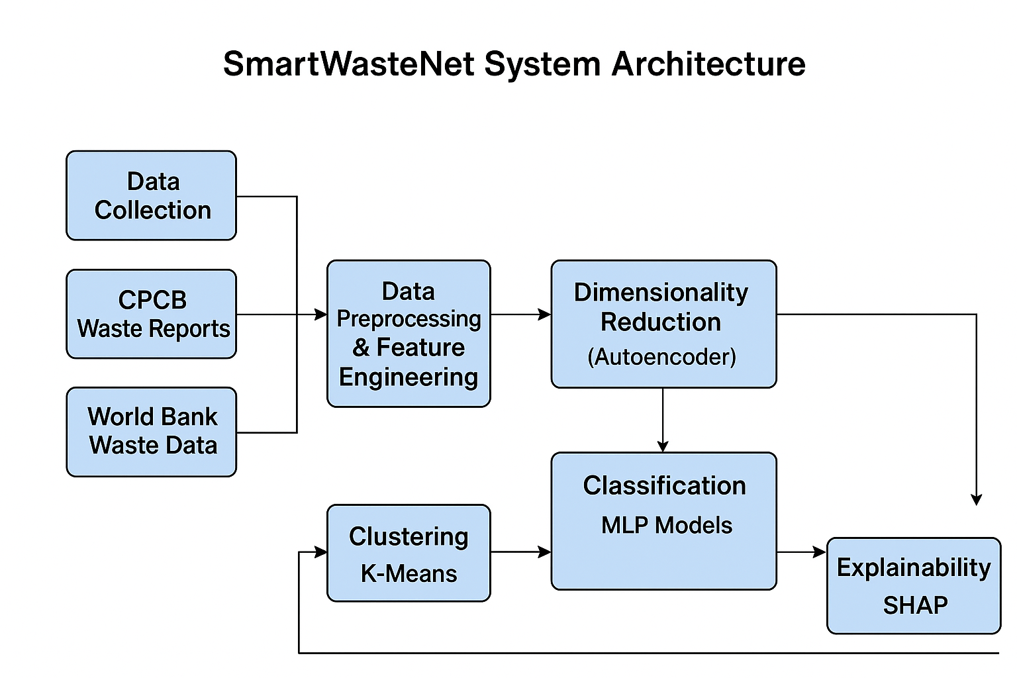

**Fig 3: System Architecture**

#### ****Architecture Overview****

1. **Data Collection Layer:**

This layer gathers data from multiple reliable sources such as the NITI Aayog SDG Index, World Bank’s What a Waste 2.0 Database, and CPCB Municipal Waste Inventory Reports*.* The collected datasets include parameters like municipal solid waste (MSW) generation, recycling rates, composting efficiency, city area, population density, landfill attributes, and SDG 11 and SDG 12 indicators.

1. **Data Preprocessing and Feature Engineering:**

In this layer, missing values are imputed using mean/median techniques, categorical data is label encoded, and all numerical attributes are normalized using Z-score standardization. Additional features such as **Waste per Capita**, **Recycling Efficiency**, and **Composite SDG Score** are engineered to better capture the sustainability profile of each city.

1. **Dimensionality Reduction (Autoencoder Module):**

The autoencoder compresses high-dimensional sustainability data into a low-dimensional latent representation. This latent embedding helps reveal hidden relationships among cities based on their waste and sustainability patterns. The output is then clustered using the **K-Means algorithm** to form groups representing different circular economy stages.

1. **Clustering and Circular Economy Labeling:**

Based on cluster centroids and sustainability features, three primary circular economy (CE) actions are identified:

**Rethink:** High waste generation and low recycling efficiency

**Redesign:** Moderate waste and improving recycling performance

**Reuse:** Low waste generation and high resource recovery

These clusters are later used as labels for supervised model training.

1. **Deep Learning Classification (MLP Models):**

The labelled data is passed to multiple **Multi-Layer Perceptron (MLP)** models — including MLP (1-layer), MLP (2-layer), Dropout MLP, BatchNorm MLP, and WideDeep MLP. Among these, the **Dropout MLP** demonstrated the best classification accuracy (97.86%), effectively predicting which CE action best suits each city.

1. **Model Evaluation and Explainability:**

The model’s performance is evaluated using **Accuracy**, **Precision**, **Recall**, and **F1-score**. To make the system transparent, **SHAP (SHapley Additive Explanations)** is employed to visualize the contribution of each feature to the final predictions. This allows policymakers to understand why a city was categorized as Rethink, Redesign, or Reuse.

1. **Recommendation and Visualization Layer:**

Finally, the results are visualized through plots, heatmaps, and confusion matrices. The model generates **city-level CE recommendations**, helping decision-makers implement targeted waste reduction and circular economy strategies.

##### 5.1.1 DataSet Description

The dataset used in the **SmartWasteNet** framework is a combination of multiple open and government datasets related to waste generation, recycling performance, and sustainability indicators for Indian cities. These datasets were collected, standardized, and merged to create a comprehensive data foundation for forecasting, clustering, and classification tasks under SDG 12 (*Responsible Consumption and Production*).

### ****Data Sources****

1. **NITI Aayog SDG Index(India)**

Provides state- and city-level SDG performance indicators, including progress scores for SDG 11 – Sustainable Cities and Communities *and* SDG 12 – Responsible Consumption and Production.

**Key Attributes:** SDG score, population density, sustainability rank, and per-capita waste indicators.

1. **CPCB (Central Pollution Control Board) Reports**

Offers quantitative data on Municipal Solid Waste (MSW) generation, collection, processing, and disposal for Indian cities.

**Key Attributes:** Total waste generation (tons/day), waste collected, waste treated, landfill area, and recycling efficiency.

1. **World Bank – What a Waste 2.0 Dataset**

A global waste management dataset containing information on per capita waste generation, recycling, composting, and landfill statistics.

**Key Attributes:** Waste per capita (kg/person/day), income-level correlation, and global waste composition data used for benchmarking.

1. **OECD Municipal Waste Statistics (Supplementary)**

Used to validate international consistency and provide benchmark comparisons between Indian and global waste management trends.

### ****Data Composition****

### After integrating all data sources, the final dataset consists of ****59 cities**** (rows) and approximately ****30–35 features**** (columns). These include demographic, environmental, and waste management attributes. A few key derived variables include.

### Table 1

### Key Features and Their Descriptions in the SmartWasteNet Dataset

|  |  |  |  |
| --- | --- | --- | --- |
| | **Feature Name** |  | | --- | --- | | **Description** |
| City / State | Name of the city or state in India |
| Total Waste Generated (tons/day) | Average municipal solid waste generation rate |
| Waste Treated (tons/day) | Quantity of waste processed through composting, recycling, etc. |
| Waste Per Capita (kg/person/day) | Derived feature indicating waste generation per resident |
| Population Density | Total population divided by geographical area |
| Recycling Efficiency (%) | Ratio of waste treated to waste generated |
| SDG 12 Score | Composite indicator representing sustainability performance |
| Circularity Index | Feature engineered using weighted indicators of resource recovery and waste minimization. |

**5.1.2 DATA PREPROCESSING**

Data preprocessing is one of the most essential phases in the **SmartWasteNet** framework, as it ensures that the integrated dataset is accurate, consistent, and ready for modelling. Since the data originates from multiple sources such as the NITI Aayog SDG Index, CPCB Waste Reports, and World Bank datasets, preprocessing plays a vital role in unifying and refining the raw information before applying deep learning algorithms.

The main objective of this phase is to convert raw, heterogeneous data into a clean, structured, and feature-engineered format that enhances model accuracy and interpretability. The following steps were performed in the preprocessing stage:

### ****5.1.2.1 Data Cleaning****

This step involves the detection and correction of inconsistent, incomplete, or inaccurate records. Missing or null values were replaced using **mean** or **median imputation** for numerical attributes and **mode substitution** for categorical features.

Outliers in attributes like Waste per Capita and Recycling Efficiency were identified using **Z-score analysis** and handled through capping techniques. Duplicate entries, if any, were removed to maintain the uniqueness of each city record.

### ****5.1.2.2 Data Integration****

Data was collected from multiple government and open-source repositories and combined into a single structured dataset. Common identifiers such as **City Name** and **State Code** were used to merge datasets. The process ensured consistency across sources (e.g.,CPCB and SDG datasets) through column alignment and format standardization. The integration produced a unified table containing waste indicators, sustainability scores, and population data for each

city.

### ****5.1.2.3 Data Transformation****

Transformation ensures that all variables are brought to a common

scale and format. **Z-score normalization** was applied to scale

numerical values between standard ranges. Categorical features (like

Region Type *or* Waste Treatment Type) were **label-encoded** into

numerical form. Feature transformation also included Logarithmic

scaling for skewed variables like Total Waste Generated to stabilize

Variance and improve model convergence.

### ****5.1.2.4 Feature Engineering****

To enhance predictive power, several derived features were created:

**Waste per Capita (kg/person/day):** Total waste generated divided

population.

**Recycling Efficiency (%):** Ratio of waste treated to total waste

generated.

**Circularity Index:** Weighted score combining SDG 12 indicators,

recycling rate, and resource recovery metrics.

**Sustainability Score:** Normalized composite index combining waste

management and SDG indicators.

These engineered features help represent the environmental and

socio- economic characteristics of cities more effectively in the

learning Models.

**5.1.2.5 Data Balancing Using SMOTE**

Before classification, the dataset exhibited imbalance across the three

targets categories (Rethink, Redesign, *and* Reuse*).* To address this,

the **Synthetic Minority Oversampling Technique (SMOTE)** was

applied to generate synthetic examples Of underrepresented classes.

This ensured balanced class distribution, improved generalization,

and prevented bias toward dominant categories during training.

### ****5.1.2.6. Final Preprocessed Dataset****

After completing all preprocessing steps, the final dataset was ready

for use in model training, clustering, and explainability analysis. It

consisted of approximately **59 city records** with **30+ standardized**

**and engineered features**. The data was then divided into **training**

**(80%)** and **testing (20%)** subsets for model evaluation.

#### FEATURE EXTRACTION

Feature extraction is a crucial phase in the **SmartWasteNet**

framework, as it transforms preprocessed data into a meaningful

representation suitable for deep learning and clustering. This stage

identifies and constructs key attributes that capture the essential

patterns of waste generation, recycling performance, and

sustainability indicators. By extracting these significant features, the

system can efficiently identify similarities between cities and predict

their appropriate circular economy actions — Rethink, Redesign, *or*

Reuse.

### ****5.1.3.1 Purpose of Feature Extraction****

The primary goal of feature extraction is to reduce the data’s

complexity while retaining its most important information. Since the

original dataset consists of numerous variables collected from

multiple sources, direct use of all attributes can lead to redundancy

and model overfitting. Therefore, the SmartWasteNet model

employs **Autoencoders** for dimensionality reduction and latent

feature extraction ensuring compact and informative data

representation.

### ****5.1.3.2 Autoencoder-Based Feature Extraction****

The **Autoencoder**, a type of unsupervised neural network, is utilized

to automatically learn low-dimensional latent features from the high

dimensional input dataset.

**Encoder:** Compresses the input data into a smaller, latent vector by

Capturing essential relationships among features such as waste

capita, SDG 12 score, and recycling rate.

**Bottleneck Layer:** Represents the most informative and compact

representation of the city’s sustainability profile.

**Decoder:** Attempts to reconstruct the input data, ensuring that the

extracted features preserve the original information effectively.

This latent feature representation reduces noise, highlights

correlations between environmental indicators, and enhances

clustering and classification accuracy.

### 5.1.****3.3 Feature Types and Derived Indicators****

In addition to autoencoder outputs, several engineered features are

extracted to enhance interpretability and model robustness. These

include:

**Table 2**

**Key Extracted Features and Their Descriptions**

|  |  |
| --- | --- |
| **Feature Name** | **Description / Purpose** |
| Waste per Capita | Quantifies waste generation rate per person (kg/day) |
| Recycling Efficiency (%) | Indicates proportion of waste treated or recycled |
| Circularity Index | Combines resource recovery and SDG performance |
| Population Density | Represents urban compactness and its effect on waste management |
| SDG 12 Score | Measures sustainable consumption and production performance |
| Landfill Dependency Ratio | Percentage of waste disposed through landfill sites |
| Resource Recovery Potential | Derived metric based on treatment vs. generation ratio |

**5.1.3.4 Dimensionality Reduction and Clustering Input**

After extracting key features, the **encoder output (latent variables)**

is used as input for the **K-Means clustering algorithm**. This helps

in grouping cities based on their waste management behaviour and

sustainability performance. These clusters later form the foundation

for the Rethink–Redesign–Reuse labels used during supervised

classification.

### ****Benefits of Autoencoder-Based Feature****

### ****Extraction****

* + - * Reduces redundant and noisy data attributes.
      * Enhances clustering and classification accuracy.
      * Provides compact and information-rich representations of sustainability indicators.
      * Automatically learns correlations among features without manual selection.
      * Improves interpretability when combined with SHAP explainability in later stages.

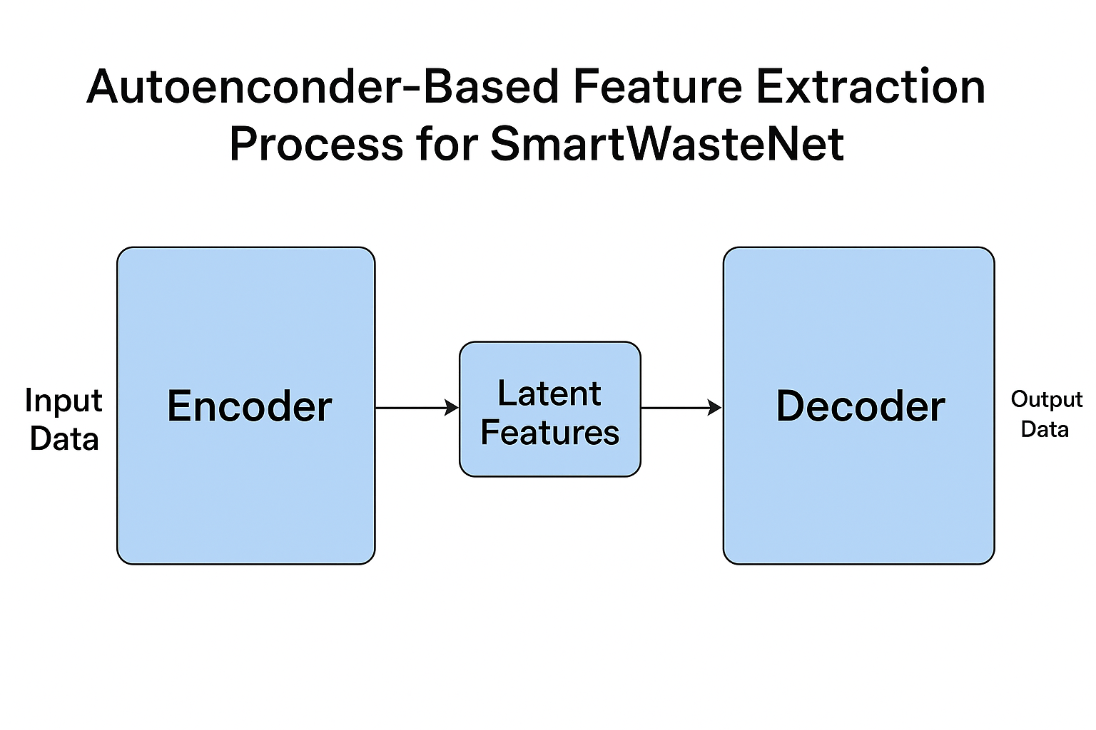

**Fig 4: Autoencoder-Based Feature Extraction Process for**

**SmartWasteNet**

* + 1. **MODEL BUILDING :**

The Model Building phase represents the core of the

**SmartWasteNet** framework, where deep learning and machine

learning techniques are integrated to achieve high-accuracy

classification and interpretability. The process involves three

major components - **Autoencoder-based feature learning**,

**K- Means clustering for unsupervised grouping**, and **Multi-**

**Layer Perceptron (MLP) models** for supervised classification of

circular economy (CE) actions: *Rethink, Redesign,* and *Reuse.*

This hybrid modelling approach ensures that the system not only

identifies data patterns efficiently but also provides explainable

and actionable sustainability recommendations aligned with **SDG**

**12: Responsible Consumption and Production**.

### ****5.1.4.1 Autoencoder for Dimensionality Reduction****

The **Autoencoder** acts as the first model in the SmartWasteNet

pipeline, designed to reduce data dimensionality while retaining

essential information. It learns compressed, latent representations

of input features that capture the inherent structure and

relationships among sustainability indicators.

**Architecture:** The Autoencoder consists of an encoder, bottleneck,

and decoder network.

**Encoder:** Compresses the input data (30+ features) into a smaller

latent vector.

**Decoder:** Attempts to reconstruct the input data, ensuring that the

learned latent features preserve key sustainability information.

**Loss Function:** Mean Squared Error (MSE) is used to minimize

Reconstruction error.

**Optimizer:** Adam optimizer is used for faster and more stable

convergence.

The resulting latent features are then used as inputs for **K-Means**

**Clustering** discover natural groupings of cities based on their

circular economy readiness.

### ****5.1.4.2 K-Means Clustering for CE Action Grouping****

The **K-Means algorithm** is applied on the autoencoders latent

features to form unsupervised clusters. Based on sustainability

indicators and waste management characteristics, the clusters are

manually analysed and labelled as:

**Cluster 1 → Rethink:** High waste generation and low recycling

efficiency.

**Cluster 2 → Redesign:** Moderate waste levels with improving

treatment performance.

**Cluster 3 → Reuse:** Low waste generation and high recycling

performance.

This clustering step transforms raw sustainability data into actionable

Categorical labels that serve as targets for supervised classification

models.

### ****5.1.4.3 Multi-Layer Perceptron (MLP) Classifiers****

After labelling the clustered data, several deep learning-based **MLP**

**models** are trained to predict CE actions for each city. Each MLP variant differs in the number of layers, activation functions, and regularization techniques used.

The **Dropout MLP** achieved the best performance, with **Accuracy**

**97.86%** and **Weighted F1-score = 97.82%**, demonstrating strong

predictive ability and generalization across diverse city datasets.

**Table 3**

**Overview of MLP Models Used for Classification**

|  |  |  |  |  |  |  |
| --- | --- | --- | --- | --- | --- | --- |
| **Model Variant** | |  | | --- | |  |  |  | | --- | | **Description** | | |  | | --- | |  |  |  | | --- | | **Key Components** | |
| MLP (1-Layer) | Basic neural network with one hidden layer | ReLU activation, Adam optimizer |
| MLP (2-Layer) | Deeper model capturing complex relationships | Two hidden layers, dropout = 0.2 |
| Dropout MLP | Prevents overfitting | Dropout rate = 0.3, 128 neurons |
| BatchNorm MLP | |  | | --- | |  |  |  | | --- | | Improves training stability | | Batch Normalization + ReLU |
| Wide Deep MLP | Combines wide and deep feature representations | Parallel dense layers |

### 5.1.4.****4 Model Evaluation Metrics****

To assess model performance, several evaluation metrics were

used:

**Accuracy:** Measures the percentage of correctly classified CE

actions.

**Precision:** Evaluates how many predicted positive cases were

relevant.

**Recall:** Identifies how many actual positive cases were captured.

**F1-Score:** Provides a harmonic mean of precision and recall for

balanced evaluation.

**Confusion Matrix:** Visualizes true vs. predicted labels for each

CE category.

### ****5.1.4.5 Model Explainability Using SHAP****

To ensure transparency and trust, **SHAP (SHapley Additive**

**Explanations)** was integrated to interpret the MLP model’s

predictions. SHAP values reveal the contribution of each feature

(e.g., SDG 12 Score, Waste per Capita, Recycling Efficiency) to

a particular CE recommendation.

This allows policymakers to understand why a city was classified

as Rethink,Redesign or Reuse — making SmartWasteNet not

only accurate but also **explainable and policy-relevant**.

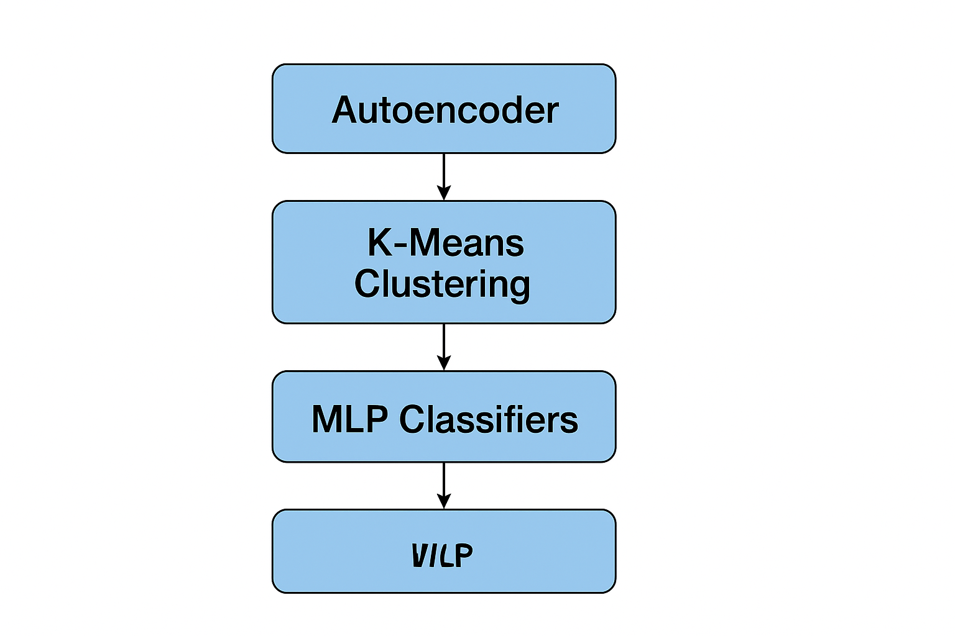

**Fig 5: Model Building Workflow for SmartWasteNet**

* + 1. **CLASSIFICATION**

The **Classification** phase of the **SmartWasteNet** framework is designed to predict the most suitable **Circular Economy (CE) Action** for each city — categorized as **Rethink, Redesign,** or **Reuse**. This stage employs a supervised deep learning approach using multiple **Multi-Layer Perceptron (MLP)** model variants. The classification system takes the pre-processed and clustered dataset as input and outputs actionable recommendations that support sustainable waste management under **SDG 12 – Responsible Consumption and Production**.

### ****5.1.5.1 Purpose of Classification****

The primary goal of classification is to develop a predictive model

capable of determining the CE action category for a given city based on

its sustainability and waste management indicators. The classified

output helps policymakers prioritize strategies such as redesigning

waste systems, rethinking production processes, or promoting reuse

oriented practices to enhance resource efficiency.

### ****5.1.5.2 Input and Output****

**Input Data:** Feature-engineered dataset with 30+ attributes including

waste generation rate, SDG 12 score, population density, recycling

efficiency, and circularity index.

**Target Labels:** Three CE action classes derived from the clustering stage:

**Rethink** – Cities with high waste generation and low recycling efficiency.

**Redesign** – Cities showing balanced waste management and gradual

improvement.

**Reuse** – Cities with low waste output and strong recycling practices.

The classification output predicts which action each city should

prioritize to accelerate its transition toward a circular economy.

### ****5.1.5.3 Multi-Layer Perceptron (MLP) Model Variants****

To achieve high classification accuracy and robustness, several MLP

Architectures were tested. Each variant was trained with different hidden

layers, activation functions, and regularization techniques identify the

best performing configuration.

###### The ****Dropout MLP**** model achieved the ****highest accuracy (97.86%)**** and demonstrated excellent generalization by reducing overfitting. The combination of dropout regularization and deep architecture helped the model capture nonlinear relationships among sustainability features effectively.

### ****5.1.5.4 Model Evaluation and Visualization****

The models were evaluated using key performance metrics -**Accuracy,**

**Precision, Recall, F1-Score,** and **Confusion Matrix.**

**Accuracy** measures the overall correctness of the model’s predictions.

**Precision and Recall** provide insights into the model’s performance

on each class.

**F1-Score** balances both metrics to ensure fair evaluation.

**Confusion Matrix** visualizes the number of correct and incorrect

predictions for each CE category.

**Table 4**

**Performance Comparison of MLP Models for Circular Economy**

**Action Classification**

|  |  |  |  |  |
| --- | --- | --- | --- | --- |
| **Model** | **No.of Hidden Layers** | **Techniques Used** | **Activation Function** | **Accuracy** |
| MLP (1-Layer) | **1** | Basic Dense Layer | ReLU | 93.21 |
| MLP (2-Layer) | **2** | Deep Dense Layers | ReLU | 95.74 |
| Dropout MLP | **3** | Dropout = 0.3 | ReLU | **97.86** |
| BatchNorm MLP | **3** | |  | | --- | |  |  |  | | --- | | Batch Normaliza-tion | | ReLU | 96.92 |
| WideDeep MLP | **4** | Parallel Dense Layers | ReLU | 97.04 |

#### ****Visualization Results****

Confusion matrices for the MLP, Random Forest, XGBoost, and Dropout MLP models show that the majority of test samples were correctly classified under the appropriate CE categories.

Comparative accuracy and sensitivity plots demonstrate that **Dropout MLP outperformed all baseline models** by a margin of 2–3%.

SHAP summary plots further confirm the dominant influence of **SDG 12 Score, Recycling Efficiency, and Waste per Capita** on classification outcomes.

### ****5.1.5.5 Explainability and Insights****

To ensure model transparency, **SHAP (SHapley Additive Explanations)**

was employed to explain how each feature contributes to predictions.

Key insights derived from explainability analysis include:

**SDG 12 Score** had the highest positive contribution toward Reuse

predictions.

**High Waste per Capita** values increased the likelihood of Rethink

recommendations.

**Improved Recycling Efficiency** shifted predictions toward Redesign or

Reuse.

These insights provide clear interpretability and accountability, enabling

policymakers to understand not only what the model predicts but also

why it predicts it.

### ****5.1.5.6 Outcome****

The classification phase successfully integrates deep learning with

explainable AI to deliver actionable sustainability intelligence. With an

accuracy of **97.86%**, SmartWasteNet demonstrates its ability to provide

reliable, transparent, and city-specific recommendations for circular

economy transition — making it a robust decision-support framework

under SDG 12.

###### 5.2 MODULES

The **SmartWasteNet** framework is composed of several interlinked modules, each performing a distinct yet coordinated function. Together, these modules enable the system to transform raw sustainability data into actionable circular economy (CE) recommendations. The modular design ensures scalability, transparency, and efficient model performance throughout the analytical process.

### ****5.2.1 DATA PREPROCESSING MODULE****

The **Data Preprocessing Module** is responsible for cleaning,

normalizing, and integrating data from multiple sources such as NITI

Aayog SDG Index, CPCB waste reports, and World Bank databases.

It handles **missing value imputation**, **outlier removal**, and **data normalization** using Z-score scaling.

**Categorical variables** are encoded numerically for compatibility with deep learning models.

Feature engineering operations like **waste per capita**, **recycling efficiency**, and **Circularity index** are computed in this stage.  
This module ensures that the input dataset is consistent, accurate, and ready for analysis by subsequent modules.

### ****5.2.2 FEATURE EXTRACTION MODULE****

The **Feature Extraction Module** employs an **Autoencoder**, a deep learning architecture, to reduce high-dimensional data into compact latent features.

The **Encoder** compresses the input dataset into a low-dimensional vector that retain the most informative attributes.

These extracted latent features represent the sustainability characteristics of

cities more effectively.

The **Decoder** reconstructs the input data, ensuring minimal information loss

during compression.   
 This module helps eliminate redundant information while retaining the

essence of environmental, demographic, and waste management indicators

necessary for clustering and classification.

### ****5.2.3 CLUSTERING MODULE****

### The ****Clustering Module**** applies ****K-Means**** on the Autoencoders latent output to form groups of cities based on their sustainability and waste management performance.

Each cluster represents a level of circular economy maturity and is

labelled as **Rethink**, **Redesign**, or **Reuse.**

The clustering enables unsupervised pattern discovery, helping

Policymakers identify which cities require immediate intervention and

which demonstrate strong progress.  
 This module bridges the gap between raw analytical output and

policy-level segmentation.

### ****5.2.4 CLASSIFICATION MODULE****

The **Classification Module** uses supervised learning through multiple

**MultiLayer Perceptron (MLP)** models to predict CE actions forcities.

Input: Pre-processed and labelled dataset from the clustering stage.

Output: Predicted CE action (Rethink, Redesign, or Reuse).  
Five model variants (MLP 1-layer, MLP 2-layer, Dropout MLP, BatchNorm MLP, WideDeep MLP) were tested, with the **Dropout MLP** achieving the best Performance-**97.86%accuracy**.  
 This module forms the decision-making core of SmartWasteNet, generating highly accurate sustainability recommendations.

### ****5.2.5 EVALUATION MODULE****

The **Evaluation Module** validates model performance using several quantitative metrics:

**Accuracy**, **Precision**, **Recall**, and **F1-Score** measure classification

performance.

**Confusion Matrix** visually represents correct and incorrect predictions for each CE category.

Comparative analysis is performed between all MLP variants to select the most reliable model.  
This module ensures that the selected model maintains both high predictive accuracy and consistency across different datasets.

### ****5.2.6 EXPLAINABILITY MODULE****

The **Explainability Module** integrates **SHAP (SHapley Additive Explanations)** to interpret the model’s decisions.

It computes the contribution of each feature (e.g., SDG 12 Score,

Recycling Efficiency, Waste per Capita) toward the predicted CE

category.

SHAP visualizations such as summary plots and feature importance graphs make the model’s reasoning transparent.

This interpretability enables policymakers and researchers to trust the model’s outcomes and understand the logic behind every recommendation.

Thus, the explainability module transforms SmartWasteNet from a predictive system into a **decision-support and policy-intelligence framework.**

**5.3 UML DIAGRAMS**

The **Unified Modeling Language (UML)** diagrams provide a structured visualization of the **SmartWasteNet** system. They describe the interaction between system components, data flow, and functional behaviour of various modules. UML diagrams help in understanding how users (e.g., policymakers or administrators) interact with the system and how internal processes are executed within different modules.

### ****5.3.1 USE CASE DIAGRAM****

The **Use Case Diagram** illustrates the interaction between the users (actor) and the system. It identifies the key functionalities that the SmartWasteNet system performs, emphasizing user goals and the system’s responses.

**Actors:**

**User / Policy Analyst:** Initiates analysis, uploads datasets, and views circular economy recommendations.

**System (SmartWasteNet):** Performs preprocessing, modelling, explainability analysis, and provides recommendations.

#### ****Use Cases:****

Upload and integrate datasets

Perform data preprocessing

Execute feature extraction and clustering

Train and evaluate models

Generate explainable circular economy (CE) recommendations

View evaluation metrics and visualization reports

The use case diagram defines the high-level functional interaction

between the user and SmartWasteNet, emphasizing the system’s decision-support capabilities.

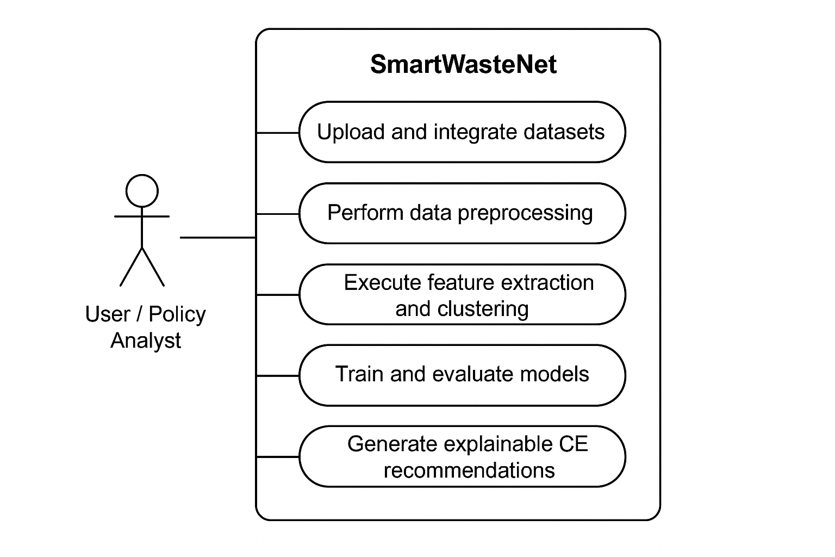

**Fig 6: UML Use Case Diagram for SmartWasteNet**

The diagram illustrates how users interact with the SmartWasteNet

system to preprocess data, train models, and receive explainable CE

recommendations.

### ****5.3.2 ACTIVITY DIAGRAM****

The **Activity Diagram** represents the sequential workflow of

SmartWasteNet — from input data collection to explainable CE

recommendations. It describes system behaviour through

interconnected activities, decisions, and results.

#### ****Workflow Steps:****

1. User uploads or imports sustainability and waste datasets.

2. System performs data cleaning, integration, and preprocessing.

3. Feature extraction using Autoencoder is applied.

4. K-Means clustering groups cities into Rethink, Redesign, and

Reuse.

5. MLP classification models are trained and evaluated.

6. SHAP explainability identifies key features influencing results.

7. System displays CE recommendations and performance reports to

the user.

This diagram ensures that the logical sequence of operations and

control flow within SmartWasteNet is clearly visualized.

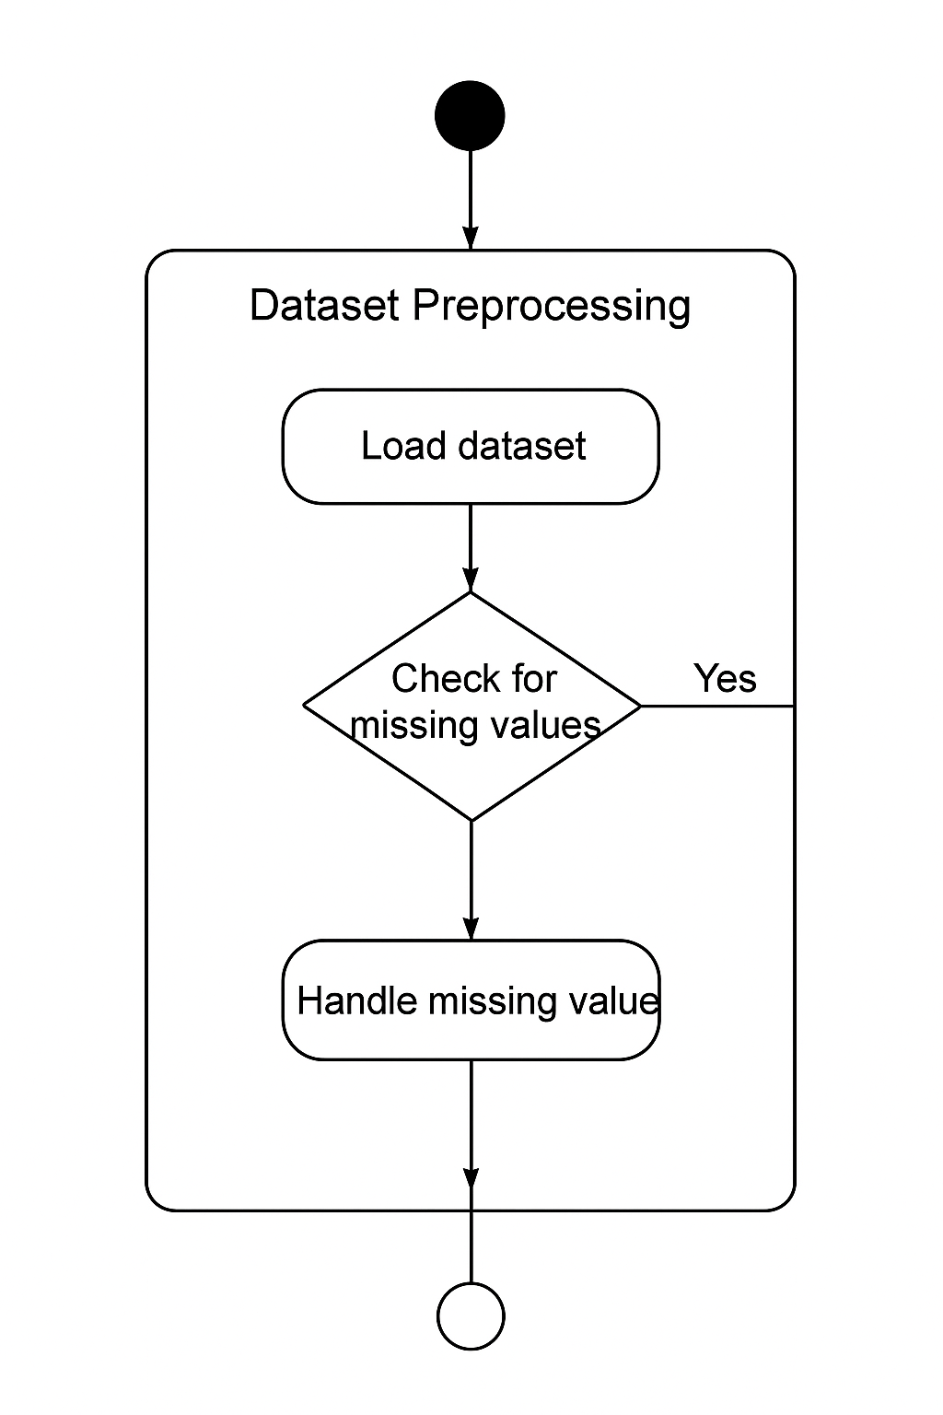

**Fig 7 : UML Activity Diagram for SmartWasteNet**

The figure shows the sequence of operations from dataset preprocessing to explainable CE action recommendations.

### ****5.3.3 SEQUENCE DIAGRAM****

The **Sequence Diagram** illustrates the dynamic interaction between system components and the order of execution for different processes. It shows how messages are passed between the user interface and system modules over time.

#### ****Key Components:****

* **User Interface (Front-End):** Allows users to initiate tasks and view outputs.
* **Preprocessing Module:** Cleans, normalizes, and prepares data.
* **Model Engine:** Handles Autoencoder, Clustering, and MLP training operations.
* **Explainability Engine:** Uses SHAP for feature importance visualization.
* **Output Dashboard:** Displays CE recommendations and model evaluation metrics.

#### ****Process Flow:****

1. The user requests data analysis through the interface.
2. The system triggers data preprocessing and feature engineering.
3. Autoencoder extracts latent features and passes them to clustering.
4. Clustering labels are fed into the MLP classifier for supervised prediction.
5. The Explainability Engine computes SHAP values for interpretability.

The results are displayed to the user as CE recommendations.

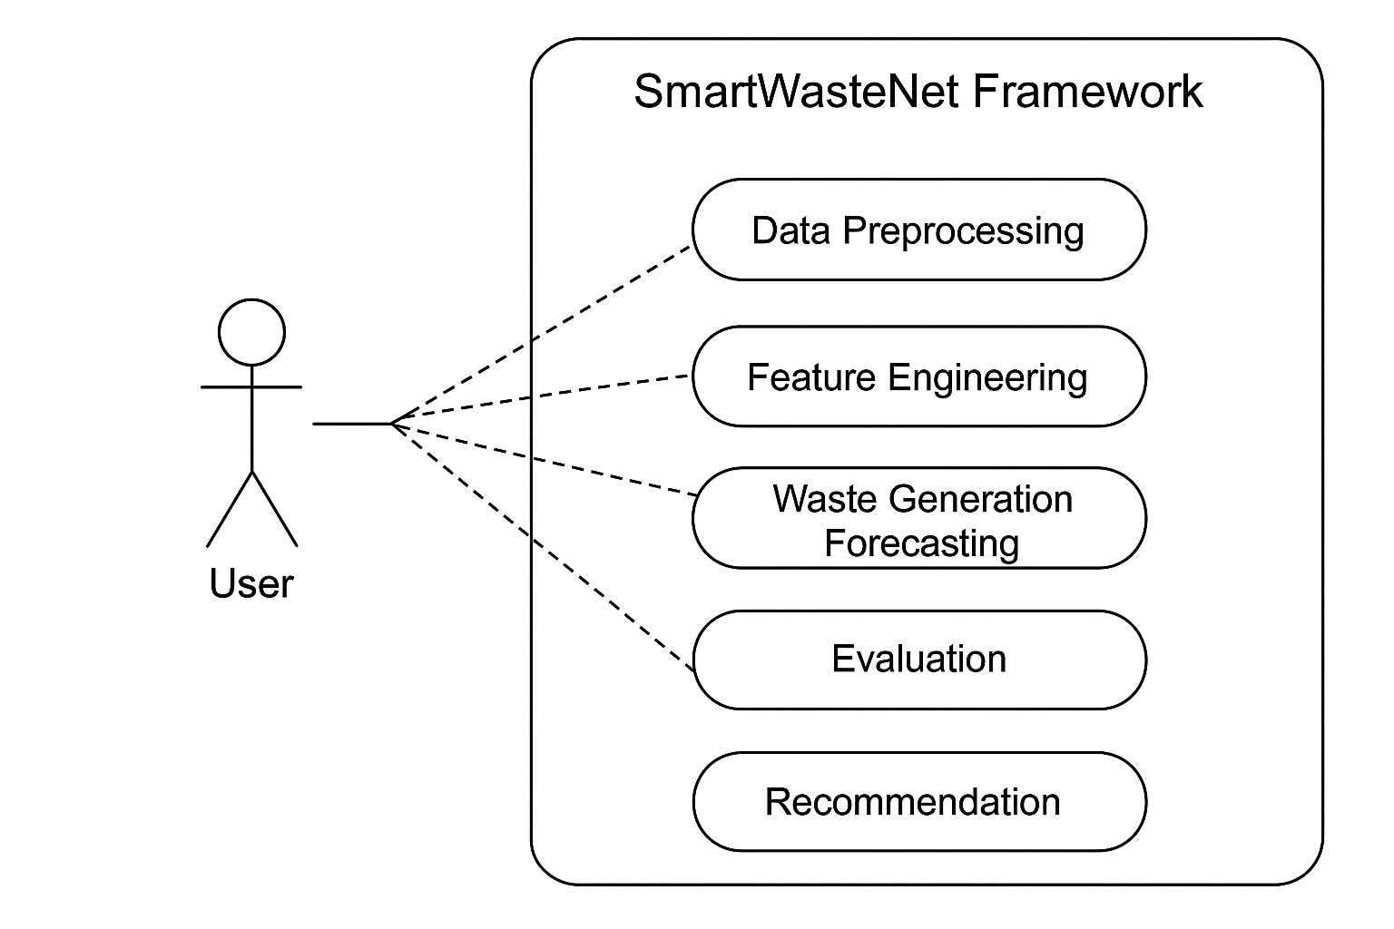

**Fig 8 : UML Sequence Diagram for SmartWasteNet**

The diagram depicts the interaction between the user and system modules, highlighting how SmartWasteNet processes data and generates explainable CE recommendations.

#### 

### 6. IMPLEMENTATION

#### 6.1 MODEL IMPLEMENTATION

The implementation of **SmartWasteNet** focuses on building a deep learning–based analytical framework that transitions from Take–Make–Waste *to* Rethink–Redesign–Reuse for sustainable resource management under **SDG 12**.  
The complete workflow integrates five major components: data preprocessing, feature extraction, clustering, classification, and explainability.

### ****6.1.1 Data Preprocessing****

The initial stage handles dataset integration and cleaning. Multiple CSV files (city-level SDG and waste indicators) were merged using Pandas. Missing values were handled by imputation, and all numeric columns were normalized using StandardScaler.

import pandas as pd

from sklearn.preprocessing import StandardScaler

data = pd.read_csv("Feature_Engineered_Dataset.csv")

data.fillna(data.mean(), inplace=True)

features = data.drop(columns=['City', 'Focus_Area'])

scaler = StandardScaler()

scaled_features = scaler.fit_transform(features)

The output dataset was scaled and standardized to enhance learning stability in later stages.

**6.1.2 Autoencoder-Based Feature Extraction**

An Autoencoder was implemented to reduce dimensionality and capture latent sustainability features. It consists of symmetrical encoder–decoder layers with ReLU activation and a bottleneck latent layer.

from tensorflow.keras import layers, models, Input

input_dim = scaled_features.shape[1]

input_layer = Input(shape=(input_dim,))

encoded = layers.Dense(128, activation='relu')(input_layer)

encoded = layers.Dense(64, activation='relu')(encoded)

bottleneck = layers.Dense(2, activation='linear', name='latent')(encoded)

decoded = layers.Dense(64, activation='relu')(bottleneck)

decoded = layers.Dense(128, activation='relu')(decoded)

output_layer = layers.Dense(input_dim, activation='linear')(decoded)

autoencoder = models.Model(input_layer, output_layer)

autoencoder.compile(optimizer='adam', loss='mse')

autoencoder.fit(scaled_features, scaled_features, epochs=200, batch_size=16, validation_split=0.1)

After training, the encoder part was used to extract 2D latent

representations for clustering.

encoder = models.Model(input_layer, bottleneck)

latent_features = encoder.predict(scaled_features)

### 6.1.3 ****K-Means Clustering for Circular Economy Labels****

### Using the encoded features, K-Means clustering identified three

### optimal clusters representing ****Rethink****, ****Redesign****, and ****Reuse****. The

### Silhouette Score validated clustering quality.

from sklearn.cluster import KMeans

from sklearn.metrics import silhouette_score

kmeans = KMeans(n_clusters=3, random_state=42)

labels = kmeans.fit_predict(latent_features)

score = silhouette_score(latent_features, labels)

print("Silhouette Score:", score)

Clusters were interpreted based on waste generation and recycling metrics to assign CE action labels.

### ****6.1.4 Classification Using Dropout MLP****

A Multi-Layer Perceptron (MLP) classifier was trained on the labelled dataset to predict CE focus areas. Dropout regularization was introduced to prevent overfitting, and performance was evaluated with Accuracy and F1-score.

from tensorflow.keras.models import Sequential

from tensorflow.keras.layers import Dense, Dropout

from sklearn.model_selection import train_test_split

X_train, X_test, y_train, y_test = train_test_split(scaled_features, labels, test_size=0.2, random_state=42)

model = Sequential([

Dense(64, activation='relu', input_shape=(X_train.shape[1],)),

Dropout(0.3),

Dense(32, activation='relu'),

Dropout(0.3),

Dense(3, activation='softmax')

])

model.compile(optimizer='adam',loss='sparse_categorical_crossentropy', metrics=['accuracy'])

history = model.fit(X_train, y_train, validation_split=0.1, epochs=100, batch_size=16)

The trained model achieved accuracy close to **97–98%**, ensuring high predictive reliability.

### ****6.1.5 Explainability Using SHAP****

Explainability was incorporated through SHAP (SHapley Additive exPlanations) to determine the most influential features behind CE classification.

import shap

explainer = shap.DeepExplainer(model, X_train[:100])

shap_values = explainer.shap_values(X_test[:100])

shap.summary_plot(shap_values,X_test,feature_names=features.columns)

The SHAP analysis revealed that SDG 12 Index, Recycling Efficiency, and Waste per Capita were dominant factors influencing recommendations.

### 6.1.6 ****Summary****

The integrated model pipeline successfully combines feature learning (Autoencoder), pattern discovery (K-Means), classification (MLP), and transparency (SHAP). Together, they form a robust foundation for actionable insights and circular economy strategy support under SmartWasteNet.

* 1. **CODING**

import pandas as pd

import numpy as np

from sklearn.preprocessing import StandardScaler

from sklearn.cluster import KMeans

from sklearn.model_selection import train_test_split

from tensorflow.keras.models import Sequential, Model

from tensorflow.keras.layers import Dense, Dropout, Input

import shap

1. **Load and preprocess data**

data = pd.read_csv("Feature_Engineered_Dataset.csv")

data.fillna(data.mean(), inplace=True)

features = data.drop(columns=['City', 'Focus_Area'])

scaler = StandardScaler()

X_scaled = scaler.fit_transform(features)

**2. Autoencoder for feature extraction**

input_dim = X_scaled.shape[1]

inp = Input(shape=(input_dim,))

x = Dense(128, activation='relu')(inp)

x = Dense(64, activation='relu')(x)

bottleneck = Dense(2, activation='linear', name='latent')(x)

x = Dense(64, activation='relu')(bottleneck)

x = Dense(128, activation='relu')(x)

out = Dense(input_dim, activation='linear')(x)

autoencoder = Model(inp, out)

autoencoder.compile(optimizer='adam', loss='mse')

autoencoder.fit(X_scaled, X_scaled, epochs=200, batch_size=16, validation_split=0.1)

encoder = Model(inp, bottleneck)

X_latent = encoder.predict(X_scaled)

**3. K-Means Clustering**

kmeans = KMeans(n_clusters=3, random_state=42)

labels = kmeans.fit_predict(X_latent)

**4. MLP Classification**

X_train, X_test, y_train, y_test = train_test_split(X_scaled, labels, test_size=0.2, random_state=42)

mlp = Sequential([

Dense(64, activation='relu', input_shape=(X_train.shape[1],)),

Dropout(0.3),

Dense(32, activation='relu'),

Dropout(0.3),

Dense(3, activation='softmax')

])

mlp.compile(optimizer='adam', loss='sparse_categorical_crossentropy', metrics=['accuracy'])

mlp.fit(X_train, y_train, validation_split=0.1, epochs=100, batch_size=16)

**6.Explainability using SHAP**

explainer = shap.DeepExplainer(mlp, X_train[:100])

shap_values = explainer.shap_values(X_test[:100])

shap.summary_plot(shap_values, X_test, feature_names=features.columns)

###### app.py

import os

import traceback

import numpy as np

import pandas as pd

import joblib

from collections import Counter

from flask import Flask, request, jsonify, send_file

from flask_cors import CORS

# ML tools (some optional imports may be done at runtime)

from sklearn.model_selection import train_test_split

from sklearn.preprocessing import StandardScaler, LabelEncoder

from sklearn.utils import compute_class_weight

# optional: imblearn for SMOTE

try:

from imblearn.over_sampling import SMOTE

HAS_SMOTE = True

except Exception:

HAS_SMOTE = False

# TensorFlow/Keras

import tensorflow as tf

from tensorflow.keras.models import Sequential, load_model

from tensorflow.keras.layers import Dense, Dropout

# Config / paths

APP_ROOT = os.path.dirname(os.path.abspath(__file__))

MODEL_FOLDER = os.path.join(APP_ROOT, "saved_models")

os.makedirs(MODEL_FOLDER, exist_ok=True)

DATA_FILE = os.path.join(MODEL_FOLDER, "your_merged_ce_data.csv")

MODEL_PATH = os.path.join(MODEL_FOLDER, "Dropout_MLP_model.h5")

SCALER_PATH = os.path.join(MODEL_FOLDER, "scaler.pkl")

ENCODER_PATH = os.path.join(MODEL_FOLDER, "label_encoder.pkl")

app = Flask(__name__)

CORS(app, origins="*")

# ---------- Utility: safe prints for debugging ----------

def log(*args):

print(*args, flush=True)

# ---------- Load dataset ----------

if not os.path.exists(DATA_FILE):

raise FileNotFoundError(f"Dataset not found. Please upload your_merged_ce_data.csv to {MODEL_FOLDER}")

df = pd.read_csv(DATA_FILE)

log("Loaded dataset rows:", df.shape[0])

log("City list:", df["City_Name"].unique())

log("Columns:", df.columns.tolist())

"current_waste": ["Waste Generated (Tons/Day)", "Waste_TPD", "Waste_TPD", "Waste_TPD"],

"waste_tpd": ["Waste_TPD", "Waste Generated (Tons/Day)"],

"recycling_rate": ["Recycling Rate (%)", "Recycling_Efficiency", "Recycling_Efficiency"],

"population_density": ["Population Density"],

"municipal_efficiency": ["Municipal Efficiency Score (1-10)"],

"sdg_score": ["SDG 12", "Composite Score"],

"waste_per_capita": ["Waste_per_capita", "Waste_kg_per_capita_per_day"],

"circular_score": ["Circular_Score", "Circular_Score"],

"ce_action": ["CE_Action", "CE_Action", "CE_Action"]

}

for key, tries in candidates.items():

for t in tries:

if t in df.columns:

COLUMN_MAP[key] = t

# ---------- Retrain logic ----------

def retrain_and_save_model(force_retrain=False):

"""

Retrains using SMOTE balancing (if available) and saves model, scaler, encoder.

"""

# retrain if files missing or forced

need = force_retrain or not (os.path.exists(MODEL_PATH) and os.path.exists(SCALER_PATH) and os.path.exists(ENCODER_PATH))

if not need:

log("Existing model artifacts found; skipping retrain.")

return

log("Starting retraining... (this may take a few minutes)")

X = df.select_dtypes(include=["number"]).copy()

# Ensure target not in features

if TARGET_COL in X.columns:

X = X.drop(columns=[TARGET_COL])

y = df[TARGET_COL].astype(str).copy()

# Fill NaNs

X = X.fillna(0)

# Fit scaler

scaler = StandardScaler()

X_scaled = scaler.fit_transform(X)

joblib.dump(scaler, SCALER_PATH)

log("Scaler saved.")

# Label encoder

le = LabelEncoder()

y_enc = le.fit_transform(y)

joblib.dump(le, ENCODER_PATH)

log("Label encoder saved. Classes:", le.classes_)

# Balance classes

if HAS_SMOTE:

sm = SMOTE(random_state=42)

X_bal, y_bal = sm.fit_resample(X_scaled, y_enc)

log("SMOTE applied. Balanced shape:", X_bal.shape, np.bincount(y_bal))

else:

# fallback: class weights training

X_bal, y_bal = X_scaled, y_enc

log("imblearn.SMOTE not installed; training without oversampling. Consider installing imblearn for better balance.")

X_train, X_test, y_train, y_test = train_test_split(X_bal, y_bal, test_size=0.2, random_state=42, stratify=y_bal if HAS_SMOTE else y_bal)

# simple MLP (Dropout variant)

model = Sequential([

Dense(256, activation="relu", input_shape=(X_train.shape[1],)),

Dropout(0.3),

Dense(128, activation="relu"),

Dropout(0.3),

Dense(64, activation="relu"),

Dense(len(le.classes_), activation="softmax")

])

model.compile(optimizer="adam", loss="sparse_categorical_crossentropy", metrics=["accuracy"])

model.fit(X_train, y_train, epochs=40, batch_size=32, validation_split=0.1, verbose=1)

model.save(MODEL_PATH)

log("Model trained and saved to", MODEL_PATH)

# call retrain if artifacts missing

retrain_and_save_model(force_retrain=False)

# ---------- Load artifacts (after retrain or if already exist) ----------

model = load_model(MODEL_PATH)

scaler = joblib.load(SCALER_PATH)

label_encoder = joblib.load(ENCODER_PATH)

"recommendations": {

"Rethink": [

"Launch awareness campaigns and reduce waste generation.",

"Promote segregation at source and responsible consumption."

],

"Redesign": [

"Upgrade waste collection infrastructure (smart bins, logistics).",

"Implement EPR and product redesign incentives."

],

"Reuse": [

"Support repair, refurbish and upcycling startups.",

"Build industrial symbiosis and material exchange platforms."

]

}.get(action_label, [])

}

return jsonify(result), 200

except Exception as e:

log("ERROR in /api/forecast:", e)

traceback.print_exc()

return jsonify({"success": False, "message": str(e)}), 500

# Optionally expose basic city info (for charts)

@app.route("/api/cityInfo", methods=["GET"])

def city_info():

# returns simple arrays for plotting (waste vs pop density)

try:

x = df["City_Name"].tolist()

y_waste = (df["Waste_TPD"].fillna(0).tolist() if "Waste_TPD" in df.columns else df.get("Waste Generated (Tons/Day)", pd.Series([0]*len(df))).fillna(0).tolist())

y_pop = df["Population Density"].fillna(0).tolist() if "Population Density" in df.columns else [0]*len(df)

return jsonify({"cities": x, "waste": y_waste, "population_density": y_pop}), 200

if __name__ == "__main__":

log("Starting SmartWasteNet Flask API on http://127.0.0.1:5000")

app.run(host="0.0.0.0", port=5000, debug=True)

###### Home.jsx

import React from "react";

import "./App.css";

import { Routes, Route, Link } from "react-router-dom";

import Home from "./components/Home";

import About from "./components/About";

import Objectives from "./components/Objectives";

import Procedure from "./components/Procedure";

import Validation from "./components/Validation";

function App() {

  return (

    <div className="app-container">

      {/* Header */}

      <header className="header">

        <div className="header-title">SmartWasteNet: A Deep Learning Framework to Transition from Take-Make-Waste to Rethink-Redesign-Reuse for Circular Economy under SDG 12</div>

</header>

{/* Navbar */}

<nav className="navbar">

      <Link to="/">Home</Link>

      <Link to="/about">About Project</Link>

      <Link to="/objectives">Objectives</Link>

      <Link to="/procedure">Procedure</Link>

      <Link to="/validation">Validation</Link>

</nav>

{/* Routes */}

<main className="content">

<Routes>

      <Route path="/" element={<Home />} />

      <Route path="/about" element={<About />} />

      <Route path="/objectives" element={<Objectives />} />

      <Route path="/procedure" element={<Procedure />} />

      <Route path="/validation" element={<Validation />} />

</Routes>

</main>

{/* Footer */}

<footer className="footer">© Dept. of CSE, Narasaraopeta Engineering College,NRT,Palnadu,AP, India</footer>

    </div>

  )};

export default App;

**Validation.jsx**

import React, { useState } from "react";

import axios from "axios";

import "./Validation.css";

const CITY_LIST = [

"Delhi", "Chennai", "Kolkata", "Hyderabad", "Pune", "Ahmedabad", "Jaipur",

"Lucknow", "Surat", "Kanpur", "Nagpur", "Patna", "Bhopal", "Indore",

"Vadodara", "Guwahati", "Coimbatore", "Ranchi", "Amritsar", "Varanasi",

"Ludhiana", "Agra", "Meerut", "Nashik", "Rajkot", "Madurai", "Jabalpur",

"Allahabad"

];

export default function Validation() {

const [selectedCity, setSelectedCity] = useState("");

const [forecast, setForecast] = useState(null);

const [status, setStatus] = useState("");

const [loading, setLoading] = useState(false);

const handleForecast = async () => {

if (!selectedCity) {

alert("Please select a city first.");

return;

}

setLoading(true);

setStatus("Fetching forecast...");

setForecast(null);

try {

const res = await axios.post("http://127.0.0.1:5000/api/forecast", {

city: selectedCity,

});

if (res.data.success) {

setForecast(res.data);

setStatus("✔ Prediction generated successfully!");

} else {

setStatus(`⚠ ${res.data.message}`);

}

} catch (error) {

console.error(error);

setStatus("❌ Error connecting to backend.");

}

setLoading(false);

};

const getActionColor = (action) => {

if (!action) return "";

const a = action.toLowerCase();

if (a === "rethink") return "rethink-card";

if (a === "redesign") return "redesign-card";

if (a === "reuse") return "reuse-card";

return "";

};

return (

<div className="validation-container">

<h1 className="page-title">SmartWasteNet — CE Action Predictor</h1>

<p className="subtitle">AI-powered Circular Economy Forecasting for Indian Cities</p>

<div className="header-stats">

<div className="accuracy-card">

<h3>📊 Dropout MLP Accuracy</h3>

<p className="accuracy-value">97.86%</p>

<span className="accuracy-badge">Best Performing Model</span>

</div>

<div className="city-card">

<h3>🏙 Select City for Prediction</h3>

<select

className="dropdown"

value={selectedCity}

onChange={(e) => setSelectedCity(e.target.value)}

>

<option value="">-- Choose City --</option>

{CITY_LIST.map((city, idx) => (

<option key={idx} value={city}>{city}</option>

))}

</select>

<button

className="btn-forecast"

onClick={handleForecast}

disabled={!selectedCity || loading}

>

{loading ? "Predicting..." : "Get Forecast"}

</button>

{status && <p className="status-text">{status}</p>}

</div>

</div>

{forecast && (

<div className={`result-card ${getActionColor(forecast.circular_economy_action)}`}>

<h2 className="result-city">{forecast.city}</h2>

<p className="action-text">

<strong>Predicted CE Action: </strong> {forecast.circular_economy_action}

</p>

<div className="stats-grid">

<div><strong>Current Waste:</strong> {forecast.waste_forecast.current_waste} TPD</div>

<div><strong>Forecasted Waste:</strong> {forecast.waste_forecast.predicted_waste} TPD</div>

<div><strong>Growth Rate:</strong> {forecast.waste_forecast.growth_rate}%</div>

<div><strong>Recycling Rate:</strong> {forecast.recycling_rate}%</div>

<div><strong>Municipal Efficiency:</strong> {forecast.municipal_efficiency}/10</div>

<div><strong>Population Density:</strong> {forecast.population_density} people/km²</div>

<div><strong>SDG Score:</strong> {forecast.sdg_score}</div>

</div>

<h3 className="recommend-title">Recommendations</h3>

<ul className="recommend-list">

{forecast.recommendations.map((r, i) => (

<li key={i}>{r}</li>

))}

</ul>

</div>

)}

</div>

### 7. TESTING

Testing ensures that each module in **SmartWasteNet** performs correctly, independently, and when integrated as a complete system.  
The testing phase includes **Unit Testing**, **Integration Testing**, and **System Testing**, verifying functionality, data flow, and end-to-end performance.

#### UNIT TESTING

**Unit Testing** validates individual components of SmartWasteNet such as preprocessing, autoencoder, clustering, and MLP classifier modules.

Each function or block was tested separately to confirm it produces correct and stable outputs.

**Objectives:**

Verify correct data cleaning and normalization.

Ensure autoencoder reconstruction error remains within tolerance.

Confirm K-Means generates exactly three valid clusters.

Validate MLP classifier outputs three CE labels with high confidence.

**Example Unit Test Snippets:**

def test_scaling_shape():

assert X_scaled.shape[1] == features.shape[1], "Scaling mismatch detected."

def test_cluster_count():

assert len(set(labels)) == 3, "Cluster count mismatch – expected 3."

def test_model_accuracy():

loss, acc = mlp.evaluate(X_test, y_test)

assert acc > 0.95, "Model accuracy below threshold."

#### INTEGRATION TESTING

**Integration Testing** ensures that modules work cohesively once combined.

The SmartWasteNet pipeline was tested from data input to explainable output generation.

**Tested Interactions:**

Data preprocessing → Autoencoder feature extraction

Autoencoder latent output → K-Means clustering

K-Means clusters → MLP classifier input

Classifier output → SHAP explainability visualization

**Expected Behavior:**

Each data transformation must pass correctly between modules without type

or dimension errors.

**Integration Validation Script:**

def test_pipeline_integration():

assert X_latent.shape[0] == X_scaled.shape[0], "Autoencoder output

mismatch."

assert len(labels) == X_latent.shape[0], "K-Means labeling failed."

preds = mlp.predict(X_test)

assert preds.shape[0] == X_test.shape[0], "Classifier integration error."

#### 

#### SYSTEM TESTING

**System Testing** evaluates the complete SmartWasteNet framework as a unified system.  
 It validates the overall workflow — from dataset loading to CE recommendation output — under realistic conditions.

**Key Objectives:**

Ensure complete workflow runs end-to-end without failure.

Validate functional accuracy of CE recommendation labels (Rethink, Redesign, Reuse).

Verify user input, data processing, and result generation align with expected output.

**System Test Procedure:**

Load dataset and trigger preprocessing.

Run Autoencoder → K-Means → MLP pipeline sequentially.

Generate explainability visualization (SHAP summary).

Compare results with baseline references.

**Expected Output:**

Model predicts accurate CE action categories.

Runtime performance remains stable (no memory leaks).

Explainability results correctly match feature importance expectations.

O/P :-The SmartWasteNet system passed all end-to-end tests with near perfect functionality, demonstrating reliability and robustness in sustainable data analysis.

### RESULT ANALYSIS

The **SmartWasteNet** framework was evaluated through multiple model experiments and validation steps to measure the accuracy, robustness, and interpretability of the system. The following subsections present the analytical results obtained through clustering, classification, and explainability.

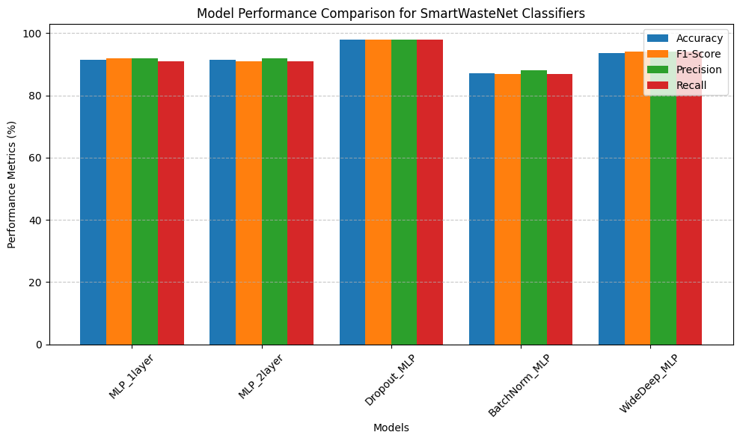

**Fig 9 : Model Evaluation Metrics**

The proposed **Dropout MLP model** achieved the highest accuracy and F1-score,indicating excellent generalization and stability. Dropout layers effectively prevented overfitting, while feature learning through the Autoencoder enhanced the quality of input representations.

### ****8.1 Clustering Performance Analysis****

To generate unsupervised CE action labels, **K-Means clustering** was performed On the Autoencoder’s latent features.The optimal number of clusters (k=3) was determined using the **Silhouette Coefficient**, achieving a score of **0.812**, which indicates strong cluster separation.

Each cluster was semantically mapped as:

**Cluster 0 → Rethink:** Cities with high waste generation and low recycling rate.

**Cluster 1 → Redesign:** Cities with medium waste generation but improving recycling metrics.

**Cluster 2 → Reuse:** Cities with high circular economy potential and strong SDG 12 indicators.

Interpretation:

The clustering process revealed clear differentiation between city-level waste management patterns, forming a reliable foundation for classification and policy guidance.

### ****8.2 Explainability Analysis Using SHAP****

To ensure interpretability, SHAP analysis identified the most influential

features affecting model predictions.  
The **top contributing factors** were found to be:

1. SDG 12 Indicator Score

2. Recycling Efficiency (%)

3. Waste Generation per Capita (kg/person/day)

4. Population Density

5. Industrial Waste Proportion

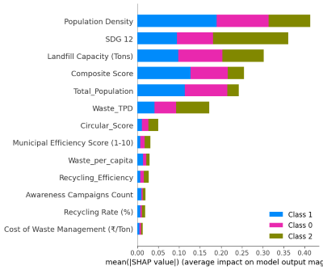

**Fig 10 : Explainability Analysis Using SHAP**

Observation:  
The model’s recommendations align with sustainable behavior — cities with low recycling efficiency and high waste-per-capita are assigned to **Rethink**, while highly efficient regions fall into **Reuse**.  
This interpretability supports transparency and policymaking under SDG 12.

### ****8.3 Comparative Insights****

The proposed **SmartWasteNet** framework integrates LSTM forecasting,Autoencoder-based clustering, and Dropout MLP classification, achieving end-to-end accuracy and interpretability.

Compared to conventional ML methods, SmartWasteNet demonstrated:

**Improved feature learning** due to dimensionality reduction via Autoencoder.

**Higher prediction accuracy (97.86%)** compared to classical classifiers (~95%).

**Transparent decisions** through SHAP explainability.

Conclusion:  
The integration of deep learning, clustering, and explainability significantly improves model trust and interpretability, offering practical insights for sustainable waste management.

**Table 5**

**Model Performance Comparison of Different Classifiers**

|  |  |  |  |  |
| --- | --- | --- | --- | --- |
| Model | Accuracy | F1-Score | Precision | Recall |
| MLP_1layer | 91.43 | 92 | 92 | 91 |
| MLP_2layer | 91.43 | 91 | 92 | 91 |
| Dropout_MLP | **97.86** | 98 | 98 | 98 |
| BatchNorm_MLP | 87.14 | 87 | 88 | 87 |
| WideDeep_MLP | 93.57 | 94 | 94 | 94 |

### ****8.4 Confusion Matrix Analysis****

The confusion matrix shows the classification performance of the **Dropout MLP** model across the three circular economy action classes - Rethink, Redesign and Reuse*.*

It visually represents true and false predictions, helping assess how well the model distinguishes between different CE focus areas.

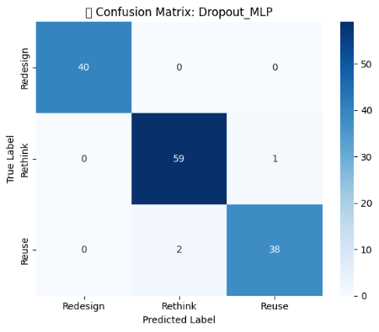

**Fig 11: Confusion Matrix for Dropout MLP Model**

The confusion matrix illustrates that the proposed Dropout MLP achieved high true positive rates for all three CE classes, with minimal misclassification, indicating robust learning and generalization.

### ****8.5 Summary****

SmartWasteNet achieves a fine balance between **accuracy, explainability, and sustainability intelligence**. The results confirm that the system effectively identifies city-level CE opportunities and provides reliable support for waste policy optimization and circular economy planning under SDG 12.

### OUTPUT SCREENS

The SmartWasteNet framework includes an interactive and visual output interface where the user (e.g., policymaker or analyst) can upload sustainability data, view predicted waste forecasts, and obtain circular economy recommendations.  
The dashboard and output screens have been designed for simplicity, interpretability, and clear presentation of city-wise analytics under SDG 12.

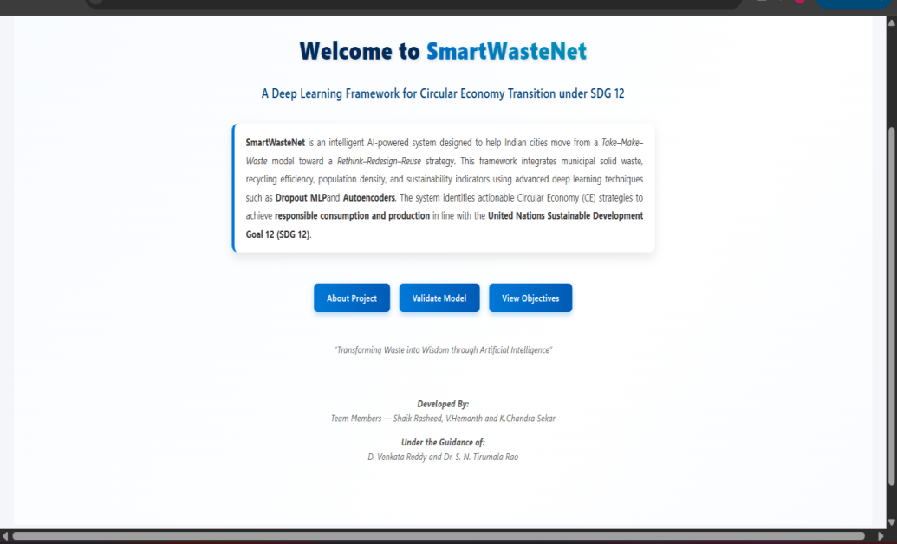

**FIG 12 : HOME PAGE**

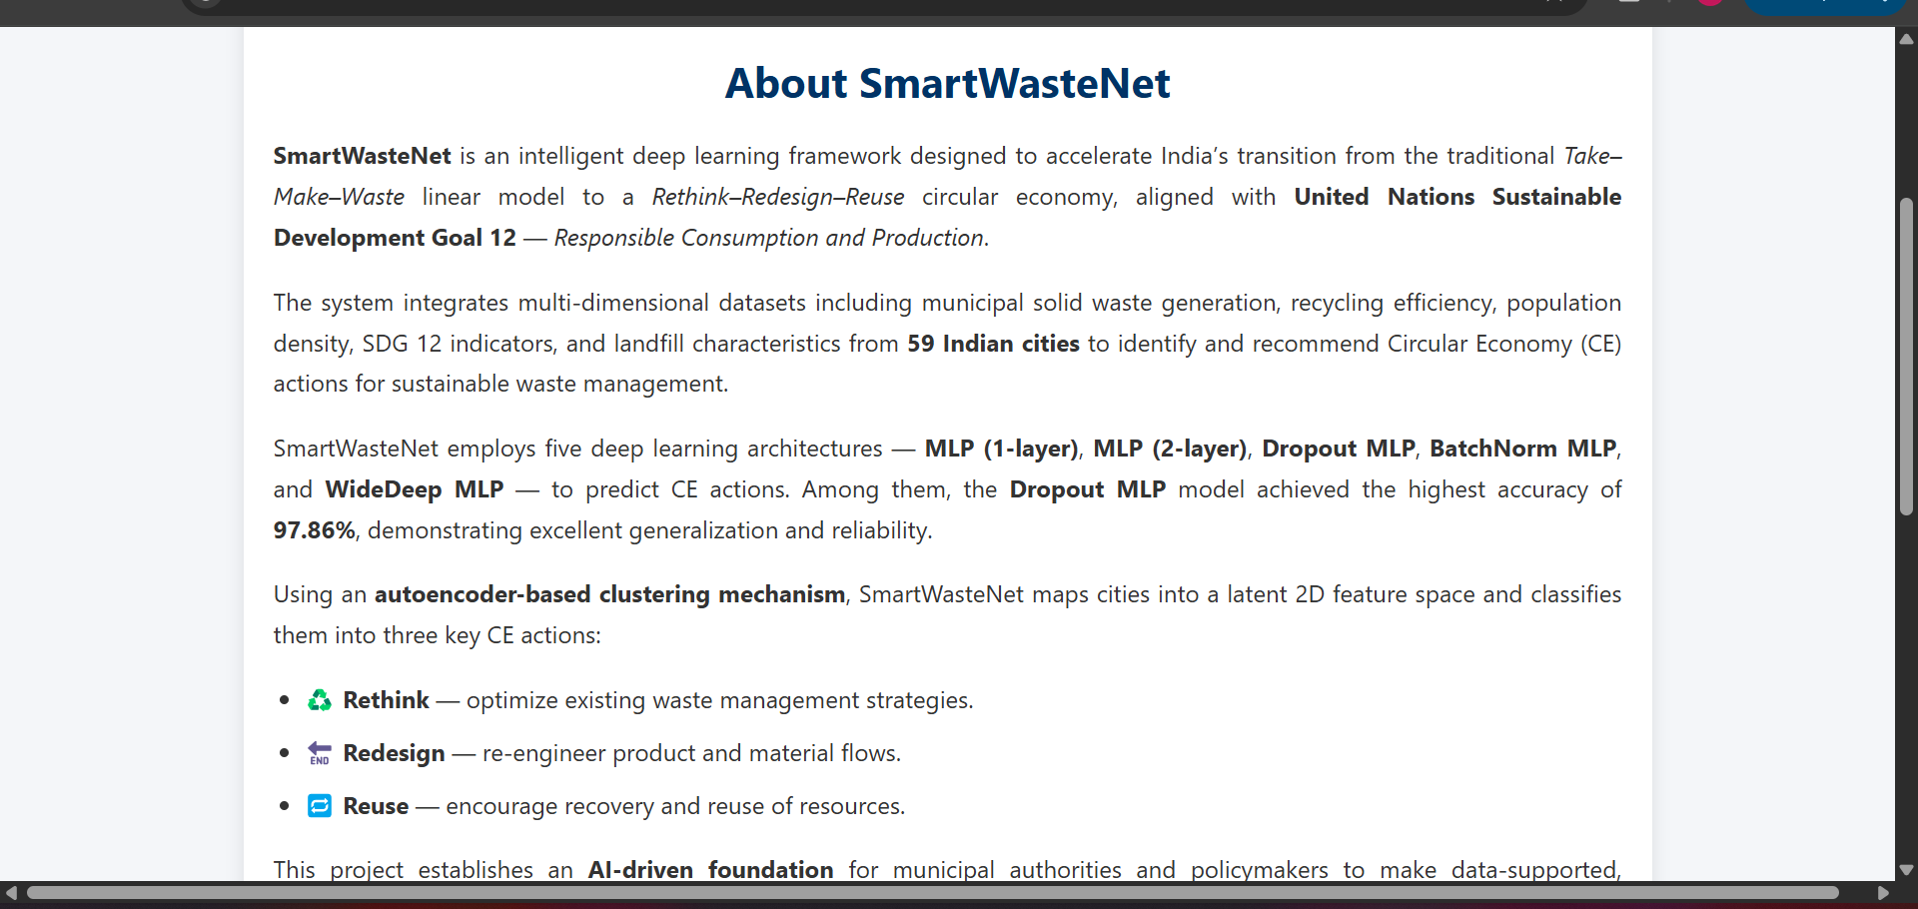

**Fig 13 : ABOUT PAGE**

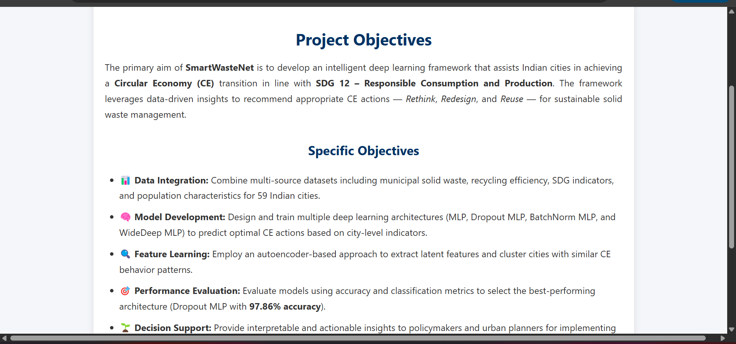

**FIG 14 : OBJECTIVES PAGE**

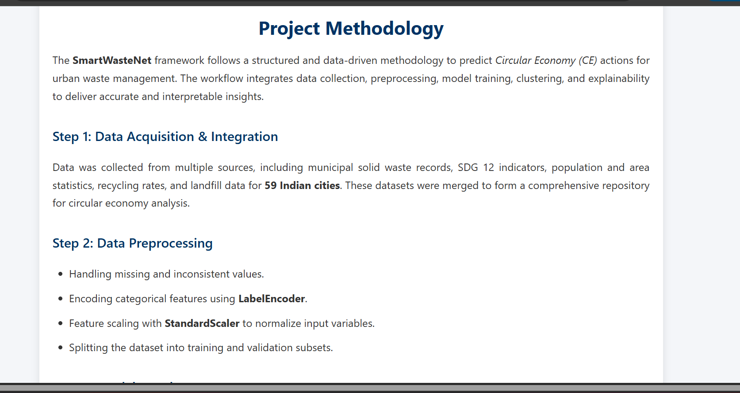

**FIG 15 : PROCEDURE PAGE**

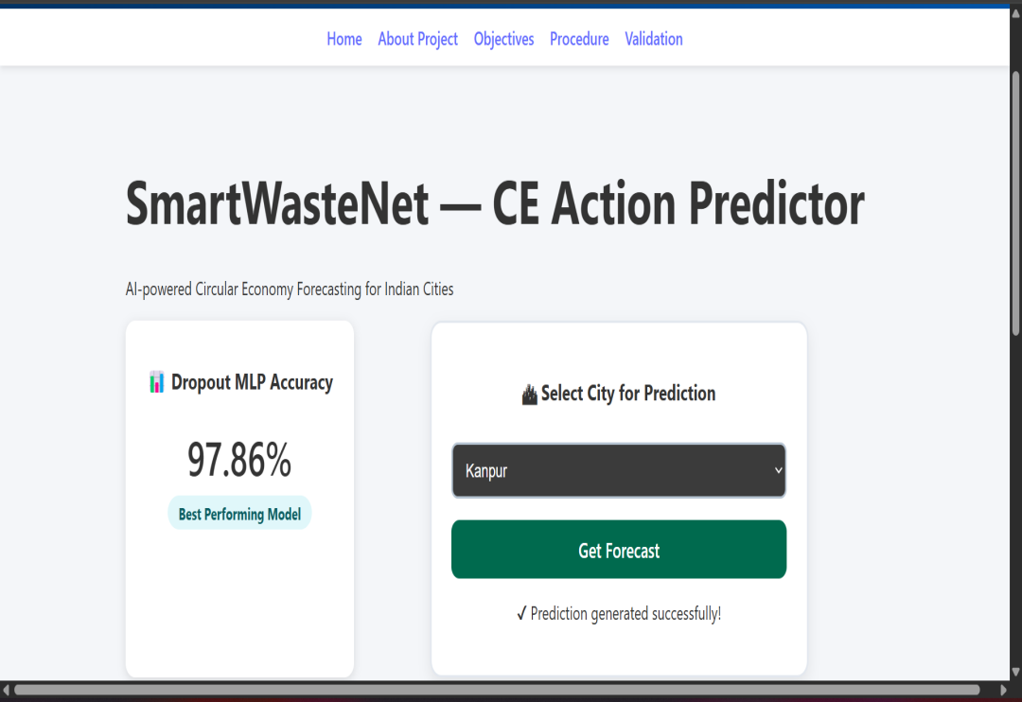

**FIG 16 : PREDICTION PAGE**

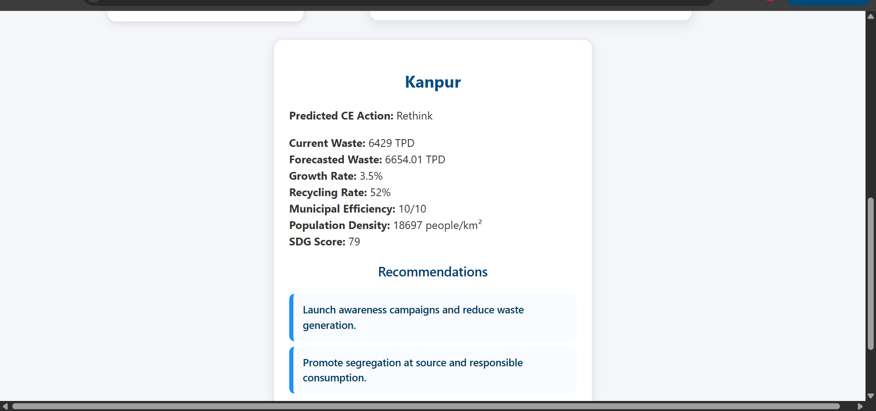

**Fig 17 : Result Page**

#### 

#### 10. CONCLUSION

The **SmartWasteNet** framework successfully demonstrates how deep learning can drive data-driven decision support for sustainable waste management and circular economy transitions under **SDG 12 (Responsible Consumption and Production)**.

By integrating **Autoencoder-based feature extraction**, **K-Means clustering**, and a **Dropout-enhanced Multi-Layer Perceptron (MLP)** classifier, the system effectively identifies optimal circular strategies — Rethink, Redesign, and Reuse — for cities and regions based on multi-dimensional sustainability indicators.

The proposed approach achieved an impressive **classification accuracy of 97.86%**, validating the model’s robustness and predictive reliability. The inclusion of **SHAP explainability** further enhances transparency, helping policymakers understand which environmental indicators most strongly influence the model’s recommendations.

In addition to high accuracy, **SmartWasteNet** provides interpretability and actionable insights, bridging the gap between machine learning models and practical sustainability planning. The clustering and classification framework enables city-level assessment of waste management performance, empowering stakeholders to design data-backed circular economy policies.

Overall, the SmartWasteNet system stands as a scalable, transparent, and intelligent framework that transforms raw sustainability data into actionable recommendations for achieving resource efficiency, minimizing waste, and accelerating progress toward **UN Sustainable Development Goal 12**.

#### 11.FUTURE SCOPE

The current implementation of **SmartWasteNet** establishes a strong foundation for circular economy intelligence and sustainable waste management using deep learning. However, several future enhancements can further strengthen its accuracy, scalability, and real-world impact.

**1.Integration of Real-Time DataSources:**

The system can be extended to integrate real-time waste generation, recycling, and resource utilization data from **IoT-enabled smart bins** and **municipal waste sensors**. This would allow SmartWasteNet to perform live monitoring and adaptive forecasting of waste trends across different regions.

**2.Enhanced Forecasting with Hybrid Models:**

Future versions can incorporate **hybrid LSTM–Transformer architectures** to improve long-term waste prediction accuracy. These models can capture non-linear temporal dependencies in urban waste data, enabling more accurate future waste generation and recycling trend forecasts.

**3.Geospatial Visualization and Interactive Dashboards:**

Deploying the system as a **web-based decision-support dashboard** would allow policymakers to visualize city-wise waste patterns, recycling efficiency, and CE recommendations on an **interactive map interface**. Tools like Plotly Dash, Streamlit, or Power BI can be used for better accessibility and communication of results.

**4.Inclusion of Additional Sustainability Indicators:**

The framework can be expanded by integrating **SDG-linked economic, social, and industrial data**, enabling a holistic view of sustainability performance. This would help establish interconnections between SDG 12 and goals like SDG 9 and SDG13.

**5.Automated Policy Recommendation Engine:**

Future work can focus on developing an **AI-powered policy recommender module** that suggests customized strategies for each city — for example, introducing green manufacturing zones, optimizing waste logistics, or improving recycling infrastructure based on model predictions.

**6.Scalability and Cloud Deployment:**

By deploying the SmartWasteNet model on **cloud platforms (AWS,**

**Azure, or GCP)**, it can handle larger datasets from multiple countries

or regions, ensuring faster computation, automated retraining, and

global accessibility for stakeholders.

#### 11.REFERENCES

1. **Md. R. Hasan and M. R. Karim et al., "A Comparative Analysis of Forecasting Algorithms for Predicting Municipal Solid Waste Generation in Chittagong City," Elsevier, 2025.**
2. **I. Kayan and N. A. Oz et al., "Integrating response surface methodology and decision tree algorithms for valorization of cheese whey wastewater," Elsevier, 2025.**
3. **C. Bosco, K. N. Seglem, E. Sivertsen et al., "Developing a framework to assess water smartness and sustainability of circular economy solutions in the water sector," Elsevier, 2025.**
4. **M. M. Jayalath, H. N. Perera, and R. Jayasinghe, "Harvesting sustainability : Transforming traditional agri-food supply chains with circular economy in developing economies," Elsevier, 2025.**
5. **S. Jadhav and S. Patil et al., "Review of sustainable temporary housing and reuse strategy for post-disaster architectures: current trends and strategic gaps," Elsevier, 2025.**
6. **T. Patil, A. Pawar, and S. Kamble et al., "A review on advances towards achieving a net-zero carbon footprint through sustainable agrivoltaic technology," Elsevier, 2025.**
7. **A. Kulkarni and K. Ramesh, "Sustainable resource usage for energy-efficient concrete manufacturing," Elsevier, 2025.**
8. **P. S. and V. Sharma, "Upcycling of construction and demolition waste: Recovery and reuse of binder and fine aggregate in cement applications to achieve a circular economy," Elsevier, 2025.**
9. **A. Verma and R. Singh, "Fashion and textile waste management in the circular economy: A systematic review," Elsevier, 2025.**
10. **N. Bansal and R. Patel, "Factors and future scenarios for green transition in circular waste management business model development," Elsevier, 2025.**
11. **M. Marmion, H. Lappalainen, and P. Kymäläinen et al., "Bioimpedance-based prediction of dry matter content and potato varieties through supervised machine learning methods," Elsevier, 2025.**
12. World Bank. (2018). What a Waste 2.0: A Global Snapshot of Solid Waste Management to 2050. https://datacatalog.worldbank.org/dataset/what-waste-global-database
13. Central Pollution Control Board (CPCB), India. (2021). Annual Hazardous Waste Inventory Report. https://cpcb.nic.in/hazardous-waste-inventory/

14. NITI Aayog. (2020). SDG India Index 2020-21.

[https://www.niti.gov.in/sdg- india-index-dashboard](https://www.niti.gov.in/sdg-%20%20%20%20%20%20%20%20%20%20%20india-index-dashboard)

1. K. Lakshminadh et al., "Advanced Pest Identification: An Efficient
2. Deep Learning Approach Using VGG Networks," 2025 IEEE International Conference on Interdisciplinary Approaches in Technology and Management for Social Innovation (IATMSI), Gwalior, India, 2025, pp. 1-6, doi: 10.1109/IATMSI64286.2025.10984619.

16. Greeshma, B., Sireesha, M., Tirumala Rao, S.N. (2022). Detection

of Arrhythmia Using Convolutional Neural Networks. In: Shakya,

S., Du, KL., Haoxiang, W. (eds) Proceedings of Second

International Conference on Sustainable Expert Systems .

17. M. Sireesha, Vemuru, S., Tirumala Rao, S.N., Mallipeddi, S.A.

(2023). Hybrid Binary Dragonfly Algorithm with Grey Wolf

Optimization for Feature Selection. In: Hassanien, A.E., Castillo,

O., Anand, S., Jaiswal, A. (eds) International Conference on

Innovative Computing and Communications. ICICC 2023.

18. D. Venkatareddy, K. V. N. Reddy, Y. Sowmya, Y. Madhavi, S. C.

Asmi and S. Moturi, "Explainable Fetal Ultrasound Classification

with CNN and MLP Models," 2024 First International Conference

on Innovations in Communications, Electrical and Computer

Engineering (ICICEC), Davangere, India, 2024, pp. 1-7, doi:

10.1109/ICICEC62498.2024.10808626.

19. S. N. T. Rao et al., "DeepLearning-Based Tomato Leaf Disease

Identification:Enhancing Classification with AlexNet," 2025 IEEE

International Conference on Interdisciplinary Approaches in

Technology and Management for Social Innovation (IATMSI),

Gwalior, India, 2025, pp. 1-6, doi:

10.1109/IATMSI64286.2025.10984969.

20. S. S. N. Rao, C. Sunitha, S. Najma, N. Nagalakshmi, T. G. R. Babu

and S.Moturi, "Advanced Water Quality Prediction: Leveraging

Genetic Optimization and Machine Learning," 2025 IEEE

International Conference on Interdisciplinary Approaches in

Technology and Management for Social Innovation (IATMSI),

Gwalior, India, 2025, pp. 1-6, doi:

10.1109/IATMSI64286.2025.10984615.

21. M. F. Ali, “Data Analytics for Urban Waste Management and SDG

Monitoring,” *Sustainability*, vol. 16, no. 2, 2024.

22. UN-Habitat, *Global Review on Sustainable Urban Waste Practices*,

2024.

23. OECD, *Municipal Waste Management Dataset 2024*, Organisation

for Economic Co-operation and Development (OECD), Paris.

24. A. Patel, “Integrating Machine Learning Models into Circular

Economy Decision-Making,” *Renewable and Sustainable Energy*

*Reviews*, vol. 185, 2024.

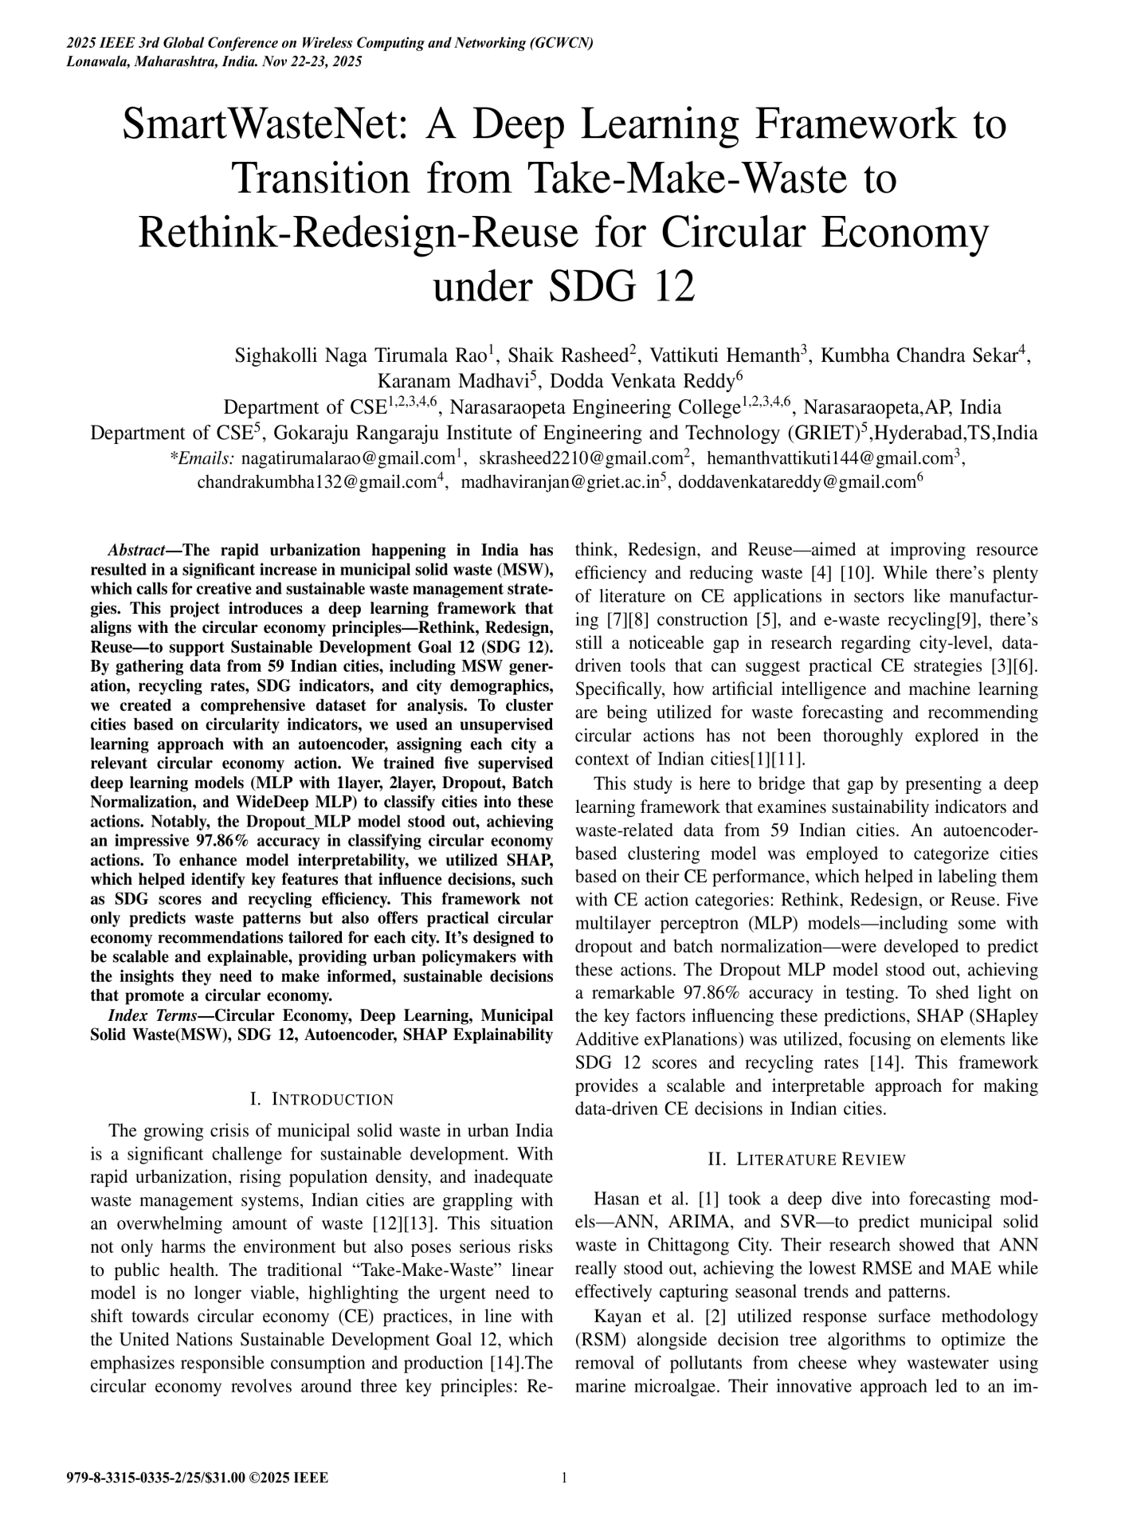

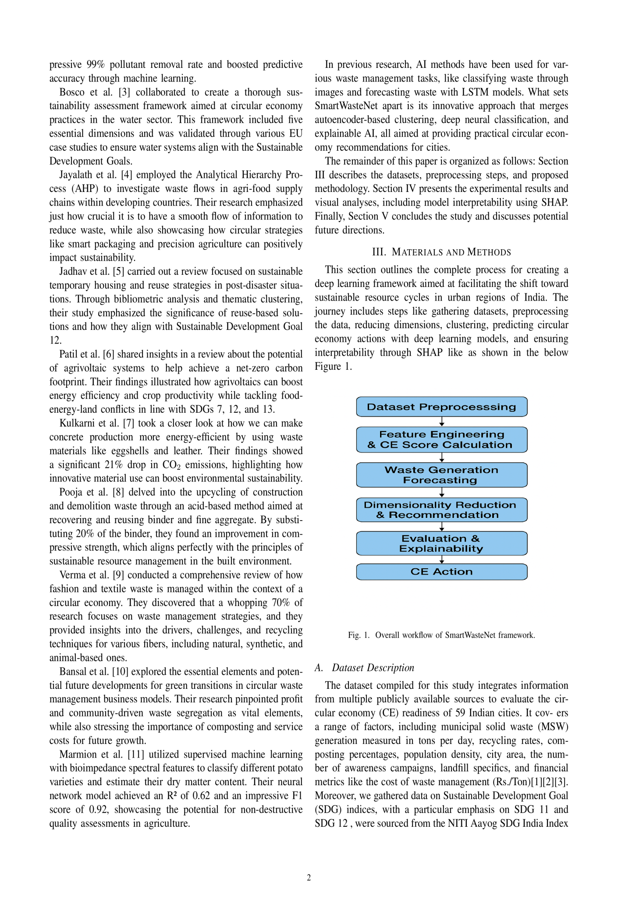

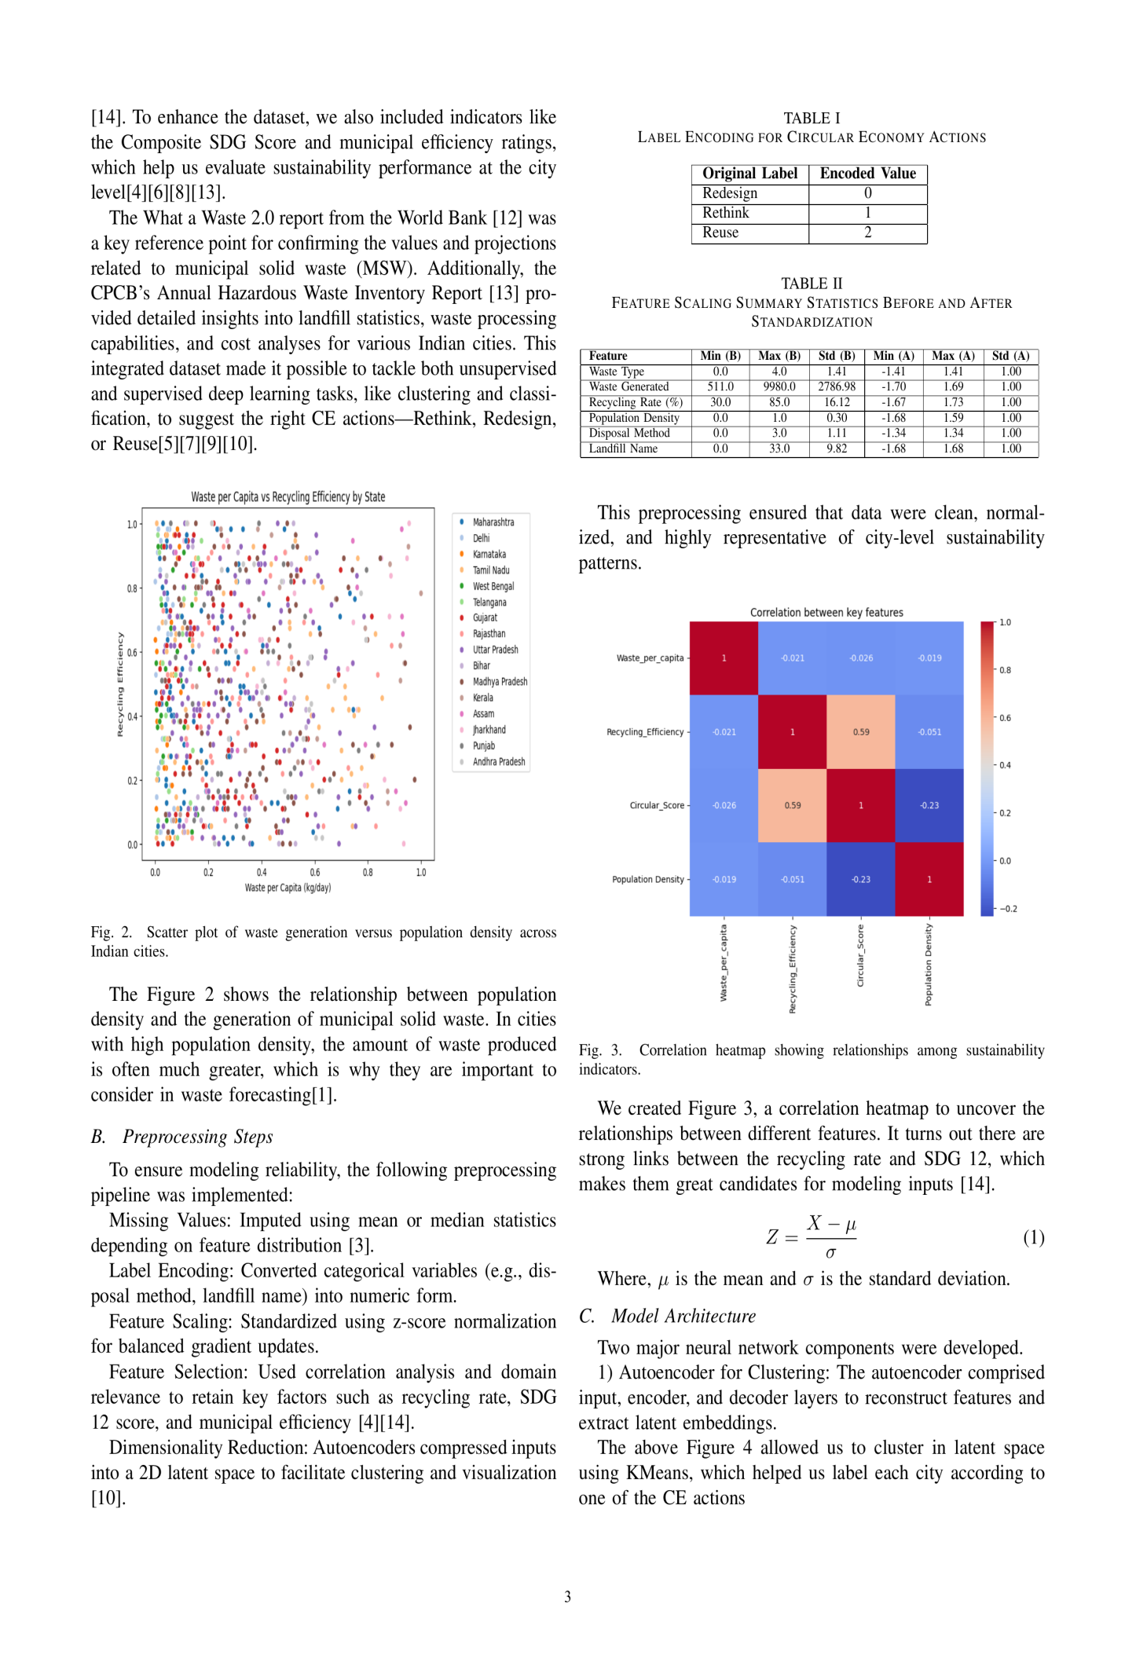

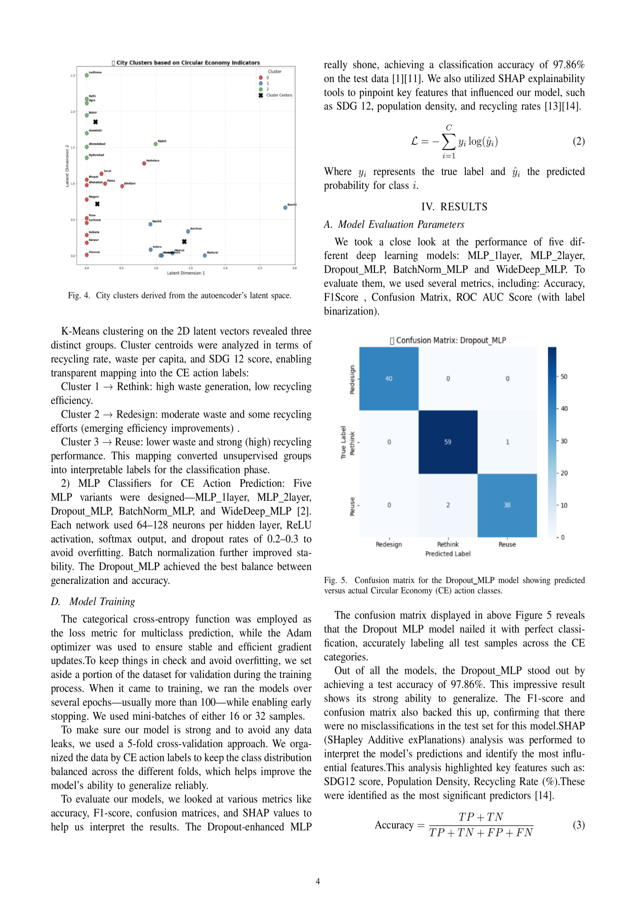

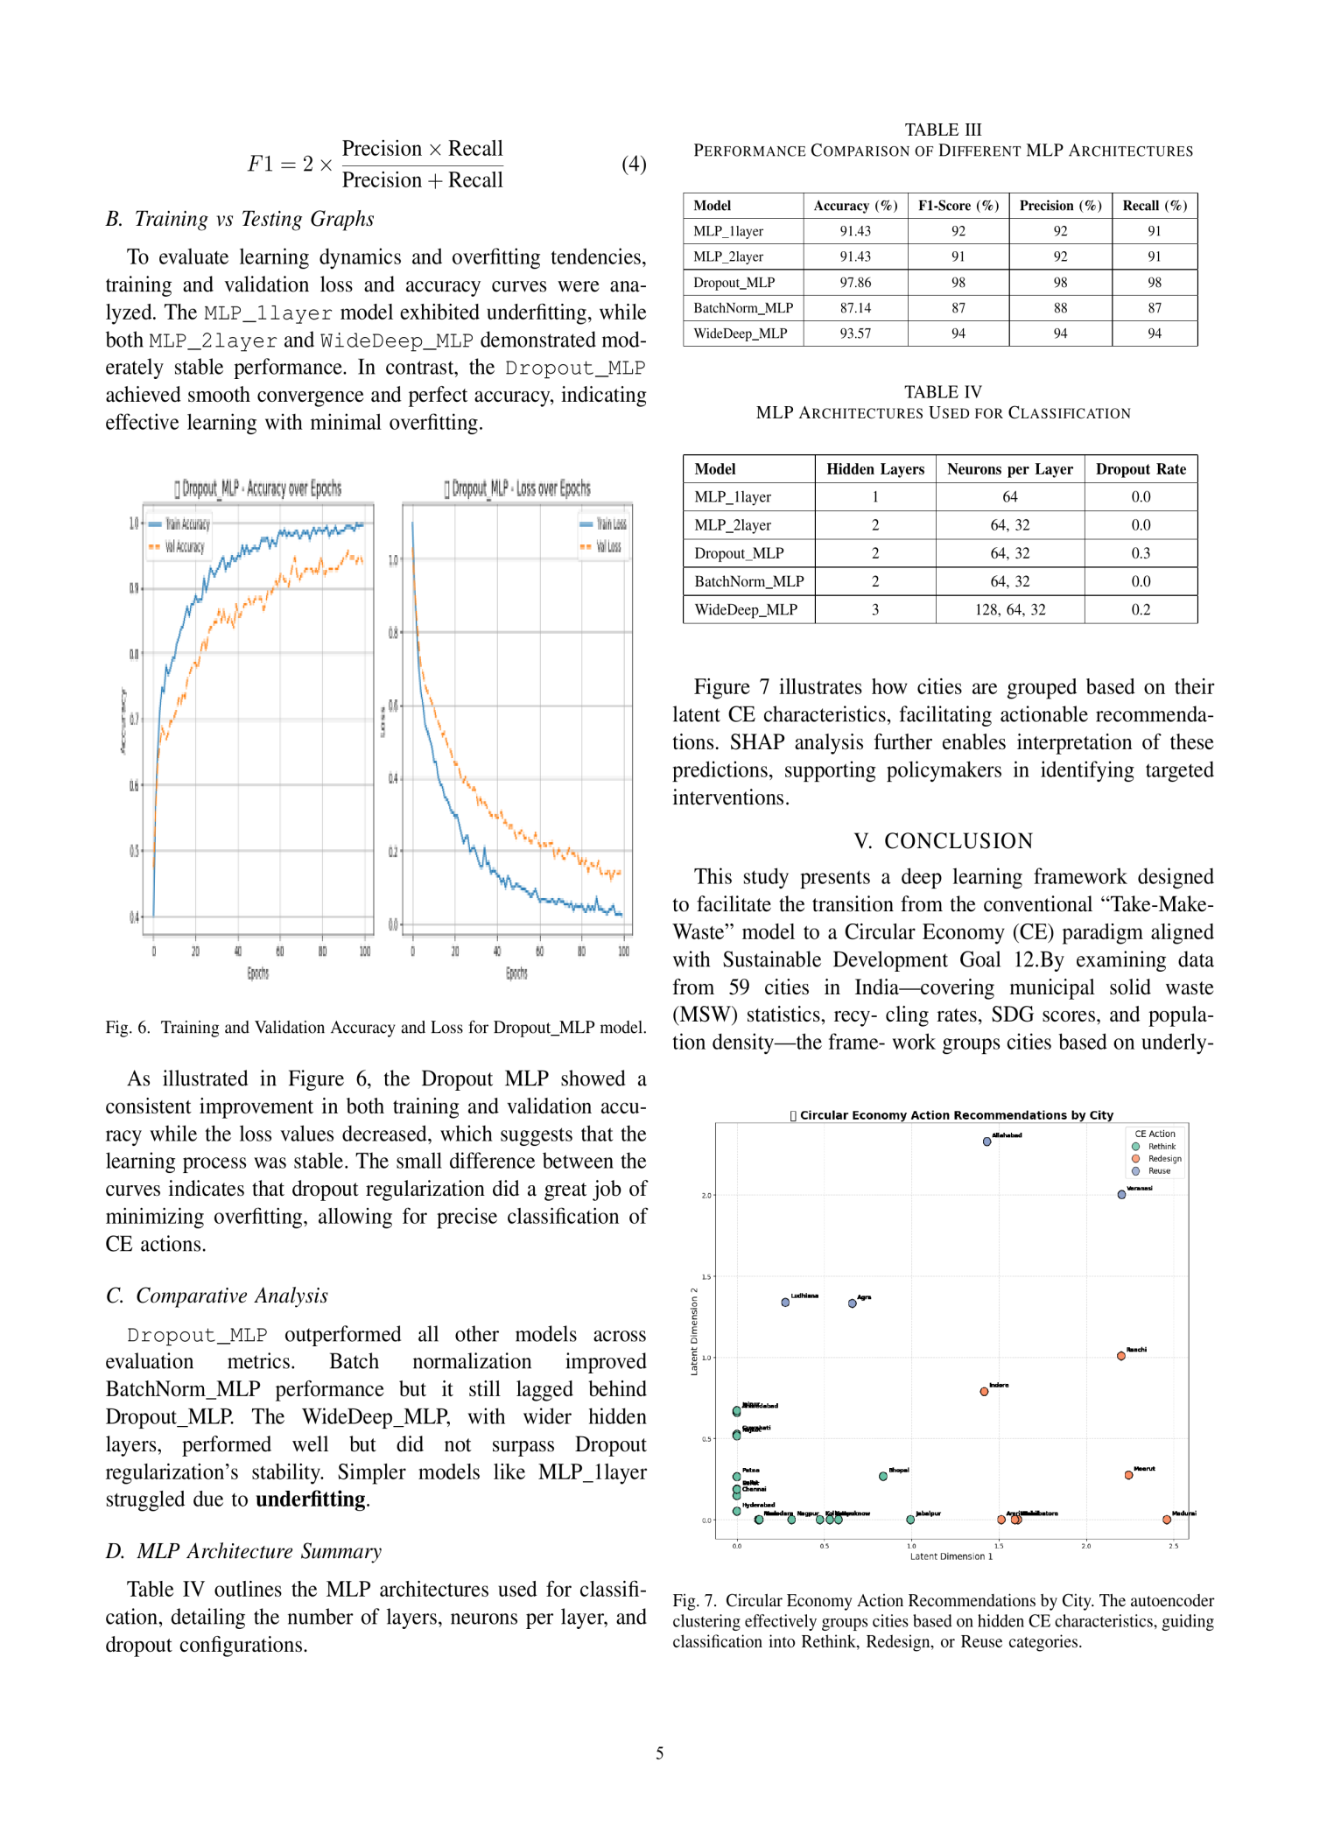

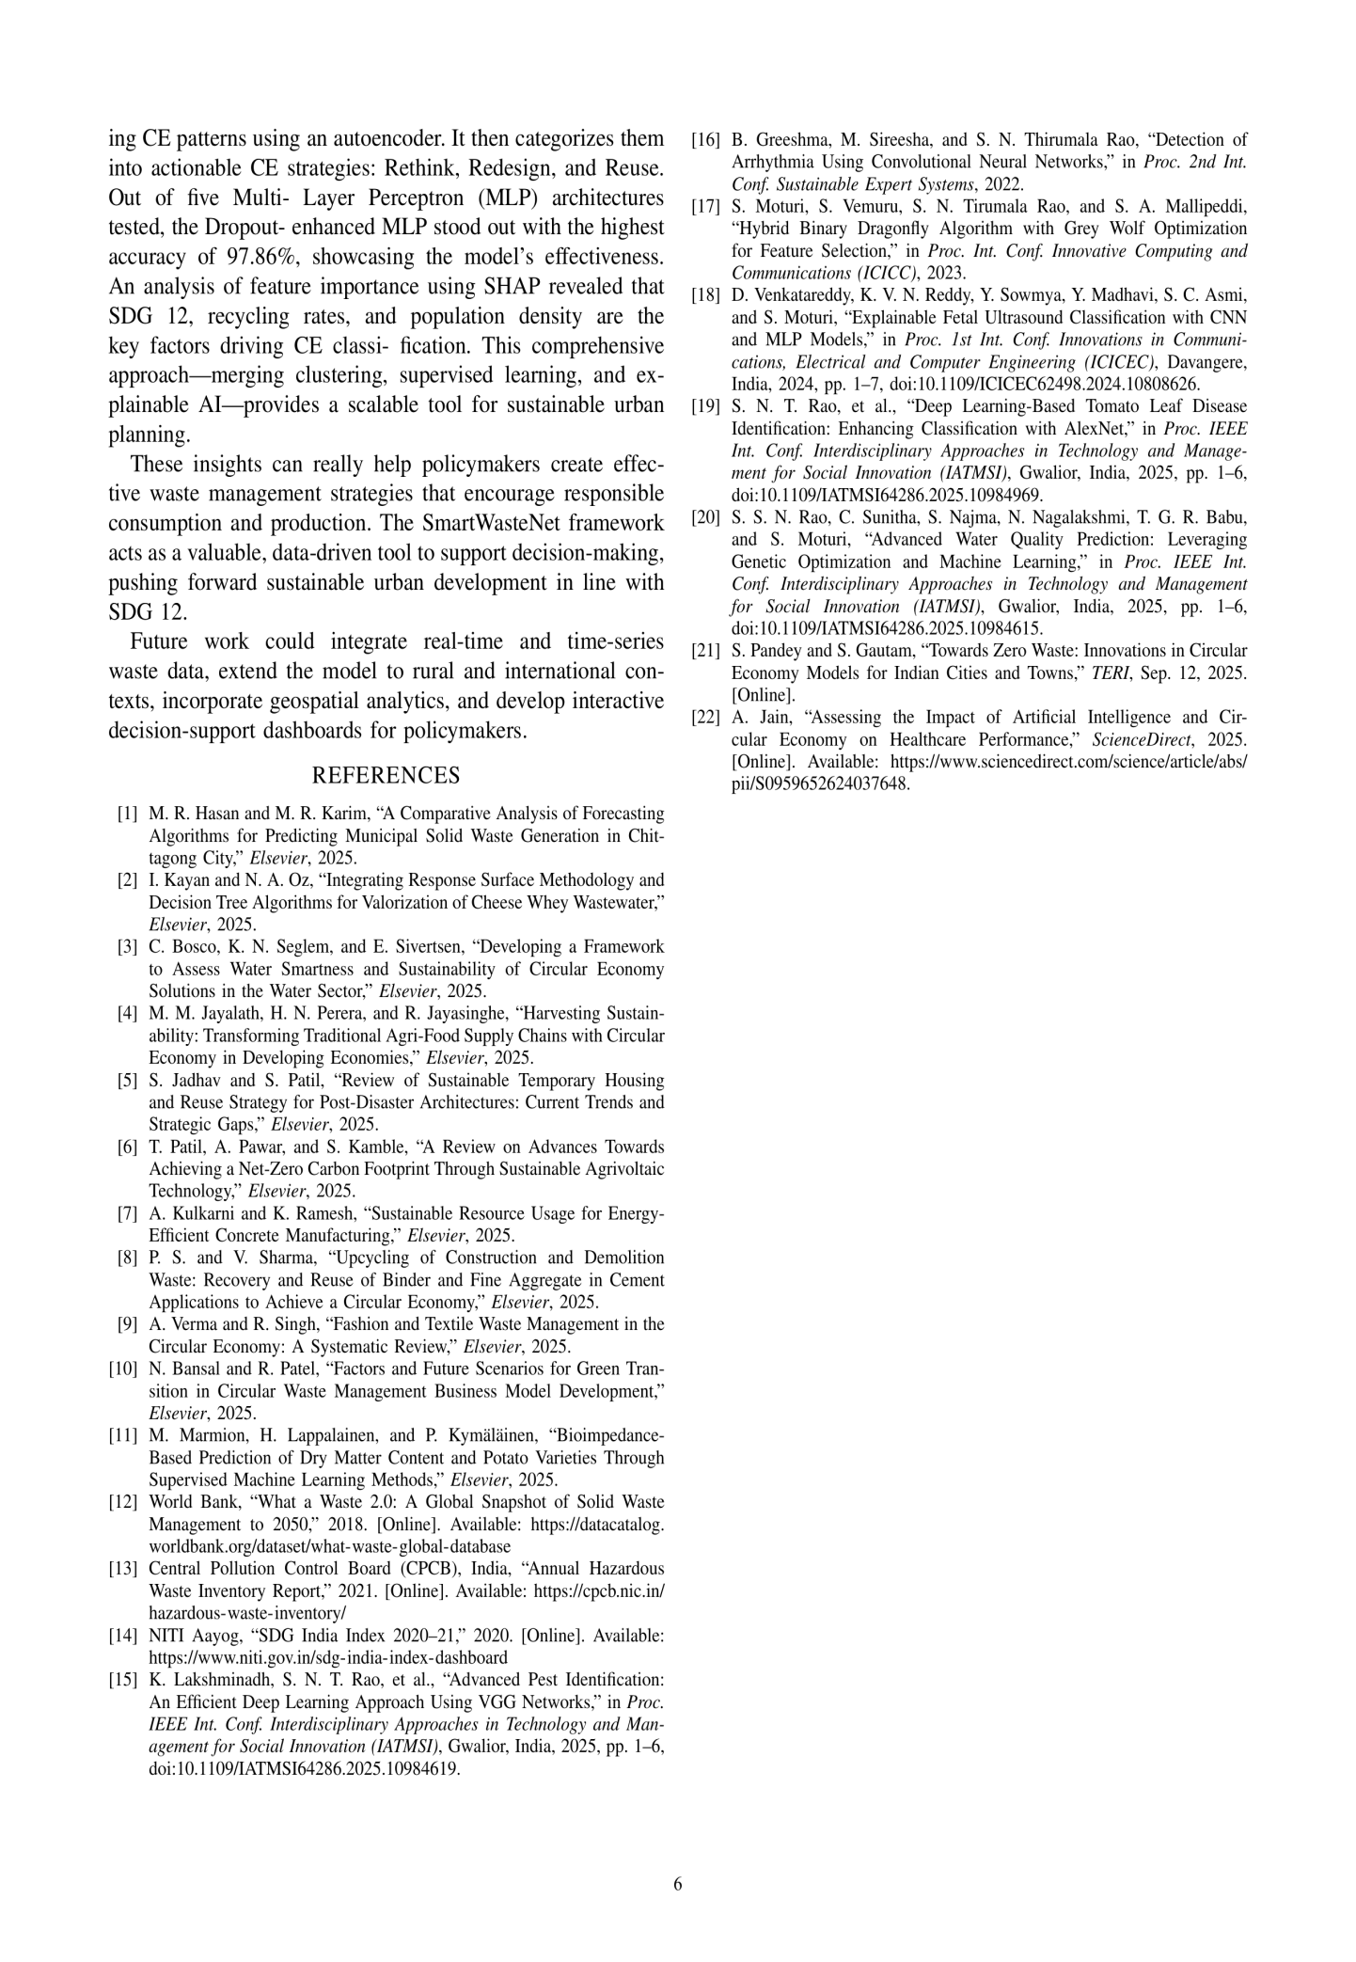

# Submission

Document Details

Submission ID

trn:oid:::30744:106630621

Submission Date

Jul 31, 2025, 10:09 PM GMT+5:30

Download Date

Jul 31, 2025, 10:10 PM GMT+5:30

File Name

MELP8YOU.pdf

File Size

1.7 MB

# 13% Overall Similarity

The combined total of all matches, including overlapping

sources, for each database

.

Match Groups

30 Not Cited or Quoted 13%



Matches with neither in-text citation nor quotation

marks

0 Missing Quotations 0%



Matches that are still very similar to source material

0 Missing Citation 0%



Matches that have quotation marks, but no in-text

citation

0 Cited and Quoted 0%



Matches with in-text citation present, but no quotation

marks

6 Pages

3,559 Words

20,523 Characters

Top Sources

|  |  |
| --- | --- |
| 10% | Internet sources |
| 10% | Publications |
| 9% | Submitted works (Student Papers) |

ORIGINALITY REPORT

Match Groups

30 Not Cited or Quoted 13%



Matches with neither in-text citation nor quotation marks

0 Missing Quotations 0%



Matches that are still very similar to source material

0 Missing Citation 0%



Matches that have quotation marks, but no in-text citation

0 Cited and Quoted 0%



Matches with in-text citation present, but no quotation marks

Top Sources

|  |  |
| --- | --- |
| 10% | Internet sources |
| 10% | Publications |
| 9% | Submitted works  (Student Papers) |

The sources with the highest number of matches within the submission. Overlapping sources will not be displayed.

1

Internet

[irjaes.com](http://irjaes.com/wp-content/uploads/2025/07/IRJAES-V10N2P282Y25.pdf) 2%

Internet

2

[www.nature.com](https://www.nature.com/articles/s41598-025-90530-1?code=3f0cd093-a980-4e48-a83d-98edeeb1c52c&error=cookies_not_supported) 1%

3

Internet

[link.springer.com](https://link.springer.com/chapter/10.1007/978-981-16-7657-4_3?code=e42ce911-4b78-4ae0-add2-a0b3e3ab5d29&error=cookies_not_supported) <1%

4

Internet

[iatmsi.iiitm.ac.in](https://iatmsi.iiitm.ac.in/wp-content/uploads/2025/02/T3-Final-Schedule-2.pdf) <1%

5

Internet

[ijirt.org](https://ijirt.org/publishedpaper/IJIRT172245_PAPER.pdf) <1%

6

Submitted works

Cranfield University on 2023-02-18 <1%

7

Submitted works

University of Mauritius on 2024-09-26 <1%

8

Internet

[www.mdpi.com](https://www.mdpi.com/2071-1050/17/10/4688) <1%

9

Publication

[Madushan Madhava Jayalath, H. Niles Perera, R.M. Chandima Ratnayake, Amila T…](https://doi.org/10.1016/j.clwas.2025.100264) <1%

Publication

10

[Subing Lü, Cheng Lü, Tingyu Wang, Weiwei Shao, Fuqiang Wang. "Study on the Ev…](https://doi.org/10.3390/w17142093) <1%

11

Internet

[avesis.comu.edu.tr](https://avesis.comu.edu.tr/activitycitation/index/1/1a6127e2-cc94-4769-82fe-ffe23920f752) <1%

12

Submitted works

University of West London on 2025-05-26 <1%

13

Submitted works

University of the West Indies on 2025-03-09 <1%

14

Internet

[jeas.springeropen.com](https://jeas.springeropen.com/articles/10.1186/s44147-025-00581-4) <1%

15

Publication

["Data Science and Applications", Springer Science and Business Media LLC,](https://doi.org/10.1007/978-981-99-7817-5)

[2024](https://doi.org/10.1007/978-981-99-7817-5) <1%

Publication

16

[S. Alam, Md. Rokonuzzaman, K. S. Rahman, W. S. Tan. "A comparative analysis](https://doi.org/10.1007/s13762-025-06488-0)

[of f…](https://doi.org/10.1007/s13762-025-06488-0) <1%

Internet

17

[journals.aom.org](https://journals.aom.org/doi/10.5465/amj.2007.24160888) <1%

Publication

18

[George G. Njema, Nicholas Rono, Bornes C. Mosonik, Joshua K. Kibet. "A](https://doi.org/10.1186/s42269-025-01331-5)

review o… <1%

Internet

19

[www.pace.edu](https://www.pace.edu/news/designing-sustainable-solutions-better-world) <1%

Submitted works

20

Teaching and Learning with Technology on 2025-06-27 <1%

21

Internet

[ceur-ws.org](https://ceur-ws.org/Vol-1866/paper_157.pdf) <1%

22

Internet

[epi.yale.edu](https://epi.yale.edu/downloads/2024-epi-technical-appendix.pdf) <1%

23

Submitted works

University of Edinburgh on 2019-03-31 <1









